

**student project management**

**Software Requirement Specification**

– Hanoi, August 2022 –

**Record of changeS**

| **Date** | **A* M, D** | **In charge** | **Change Description** |
| --- | --- | --- | --- |
| 10/Aug | A | TungDS | Thêm mô tả chức năng Home + Dashboard |
| 10/Aug | A | SonDH | Thêm mô tả chức năng User Register |
| 10/Aug | A | CuongNM | Thêm mô tả chức năng User Login |
| 10/Aug | A | DatDX | Thêm mô tả chức năng Setting List |
| 10/Aug | A | TuanNQ | Thêm mô tả chức năng Setting Details |
| 13/Aug | A | TungDS | Thêm mô tả chức năng Iteration List + Iteration Details |
| 14/Aug | A | TungDS | Thêm screen flow |
| 14/Aug | A | SonDH | Thêm mô tả chức năng User profile + Change password |
| 14/Aug | A | DatDx | Thêm mô tả chức năng User List + User Details |
| 14/Aug | A | TuanNQ | Thêm mô tả chức năng Subject List + Subject Details |
| 16/Aug | M | TungDS | Cập nhật cho chức năng Iteration List |
| 16/Aug | A | TungDS | Thêm mô tả chức năng User authorization + Criteria List + Criteria Details |
| 16/Aug | A | DatDx | Thêm mô tả chức năng Class Setting List + Class Setting Details |
| 17/Aug | A | DatDx | Thêm mô tả chức năng Milestone List +Milestone Detail |
| 18/Aug | A | DatDx | Thêm mô tả chức năng Milestone submit + Student Evaluation |
| 19/Aug | A | TuanNQ | Thêm mô tả chức năng Class List + Class Details |
| 19/Aug | A | TuanNQ | Thêm mô tả chức năng Issue List + Issue Sync |
| 19/Aug | A | TuanNQ | Thêm mô tả chức năng Iteration Evaluations |
| 20/Aug | A | TungDS | Thêm mô tả chức năng Tracking Update + Tracking Submit |
| 25/Aug | M | TungDS | Cập nhật màn hình access forbidden cho User Authorization |
| 25/Aug | A | TungDS | Thêm mô tả chức năng Web Contact |
| 25/Aug | M | DatDx | Cập nhật chỉnh sửa chức năng Class Setting List + Class Setting Details + Milestone List + Milestone Detail |
| 26/Aug | M | DatDx | Cập nhật chỉnh sửa chức năng Milestone submit + Student Evaluation |

*A - Added M - Modified D - Deleted

**Table of Contents**

**I. Overview** **7**

1. Introduction 7

2. System Functions 7

a. Screen Flow 7

b. Screen Details 8

c. User Authorization 10

d. Non-Screen Functions 11

**II. Functional Requirements** **12**

1. Home: 12

2. User register: 13

3. User login: 14

4. Dashboard: 14

5. Setting Management: 17

5.1 Setting List 17

5.2 Setting Details: 18

6. Subject Management: 18

6.1 Subject List 18

6.2 Subject Details 19

7. Iteration Management: 20

7.1 Iteration List 20

7.2 Iteration Details 22

8. User Profile: 23

9. Change password: 24

10. User Management: 25

10.1 User List 25

10.2 User Details 26

11. Subject Setting: 27

11.1 Subject Setting List: 27

11.2 Subject Details 28

12. User Authorization 29

13. Criteria Management 30

13.1. Criteria List 30

13.2. Criteria Details 31

14. Class Management 31

14.1. Class List 31

14.2. Class Details 32

15. Class Setting Management 32

15.1 Class Setting List 32

15.2 Class Setting Details 33

16. Milestone Management 34

16.1. Milestone List 34

16.2. Milestone Details 35

16.3 Milestone Submits 36

17. Student Evaluation 36

18. Issue Management 37

18.1. Issue List 37

18.2. Issue Sync 37

19. Iteration Evaluation 37

20. Tracking Update 38

21. Tracking Submit 39

22. Team List: 40

23. Team Detail: 41

24. Student: 42

24.1. Student list: 42

24.2. Student import: 42

25. Web Contact: 42

# I. Overview

## 1. Introduction

The web-based student project management system makes information management quick, convenient and inexpensive, providing top management services and solutions. The system is designed to meet the needs of users.

Main user:

* Student
* Manager
* Trainer
* Admin

The website allows to manage active projects, participants and information related to them. Users can add, edit and delete projects and participants' information based on user rights

## 2. System Functions

#### a. Screen Flow

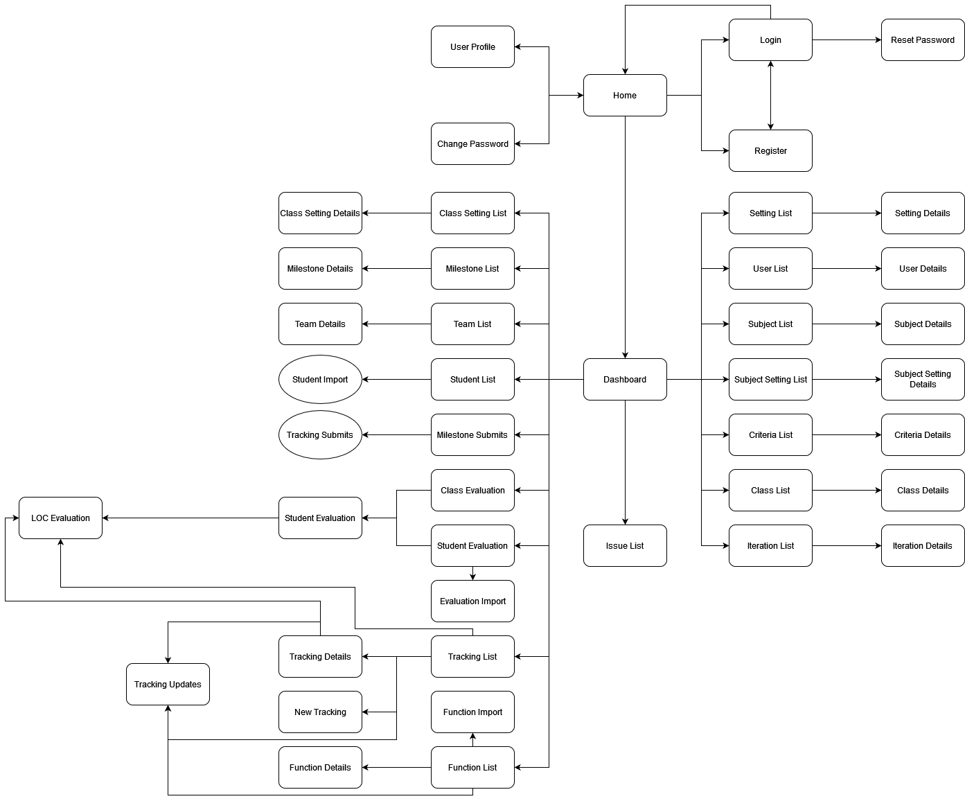

#### b. Screen Details

| **#** | **Feature** | **Screen** | **Description** |
| --- | --- | --- | --- |
| 1 | Common | Home | Default screen where all users can visit. There have information of system, contact of developer. The site can lead to login page and register page |
| 2 | Common | User Register | Screen where users can create new account with personal information. Click Submit to submit new account |
| 3 | Common | User Login | Screen where the user logs into the system with the registered account. If the account or password is wrong, the system will notify the user |
| 4 | Common | Dashboard | The screen shows all the main functions of the system, the admin will have access to the most functions, different roles will display a different number of functions depending on the user's rights. |
| 5 | Admin | Setting List | Show the paginated list of settings and its properties. Only admin can filter the setting by type, status  Allow the admin to search settings by value. The list is sortable by id, type, value, order, status. From each setting, the admin can choose to view, activate/deactivate, or edit it. The page also has the button/link that allows the admin to add new setting |
| 6 | Admin | Setting Details | Show detailed user information, from that allow the user to edit setting information |
| 7 | Common | Password Reset | Allow user to reset password using registered email in case user forgot password |
| 8 | Common | User Profile | Display information about the user who is logged in to the system |
| 9 | Common | Password Change | The user can access this screen from the dropdown on the header. At this screen the user will enter the old password, the new password and click "Change Password" to change the password |
| 10 | Admin | User List | This screen will display a list of users in the system, will have the functions of searching for users, adding users |
| 11 | Admin | User Details | This screen will display the user's information, from this screen can update the information the user |
| 12 | Admin | Subject List | Display the list of subjects, each user role will see different subjects. This screen has the functions of searching, adding and editing subjects |
| 13 | Admin | Subject Details | Display the information of the subject, with the functions of updating subject information |
| 14 | Manager | Subject Setting List | Show the paginated list of settings (include settings' id, type, value, order, status):  The admin can filter the setting by type, status  Allow the admin to search settings by value  The list is sortable by id, type, value, order, status  From each setting, the admin can choose to view, activate/deactivate, or edit it  The page also has the button/link that allows the admin to add new setting |
| 15 | Manager | Subject Setting Details | Show detailed user information (type, value, order, description, status), from that allow the user to add new, view or edit setting information |
| 16 | Manager | Iteration List | Displays the list of iterations of the subject, has search functions, adds iterations |
| 17 | Manager | Iteration Details | Display the contents of the iteration, perform operations to edit the content of the iteration |
| 18 | Manager | Criteria List | Displays the list of criteria of the evaluation, has search and filter functions |
| 19 | Manager | Criteria Details | Display the contents of the criteria, perform operations to edit the content of the criteria |
| 20 | Manager | Class List | Displays the list of classes, has search and filter functions |
| 21 | Manager | Class Details | Display the information of class, with the functions of updating class information |
| 22 | Trainer | Class Setting List | This screen will display a list of class setting in the system, will have the functions of searching for class setting, edit class setting |
| 23 | Trainer | Class Setting Details | This screen will display the class setting's information, from this screen can update the information the class setting |
| 24 | Trainer | Milestone List | This screen will display a list of Milestone in the system, will have the functions of searching for milestone, edit milestone |
| 25 | Trainer | Team List | display a list of on-going teams and projects |
| 26 | Trainer | Team Details | show detail of a team |
| 27 | Trainer | Student List | Filters: Team, Status  Columns: Team, Full Name, Email, Roll Number, Team Leader, Status  The list is sort automatically by the Team Code  Row Actions: Change Team, Set As Team Leader, Activate/Deactivate  Global Actions: Filter, Search (by Full Name, Email, Roll Number), Export  Roles: trainer ~ full access, student ~ read only  Status: Active, Inactive |
| 28 | Trainer | Student import | Team, Full Name, Email, Roll Number, Team Leader, Status |
| 29 | Student | Function List | the list of functions being performed by the student group |
| 30 | Student | Function Detail | details of the function being performed |
| 31 | Student | Function Import | Add function to the system to update the list |
| 32 | Tracking | Tracking List | Show list tracking , search , add, remove update |
| 33 | Tracking | Tracking Detail | Ajdust functions for implementing in the milestone name |
| 34 | Tracking | New Tracking | Show tracking detail , History tracking , evalution loc and update |
| 35 | Student | Issue List | the list of issues being performed by the student group |
| 36 | System | Issue Sync | Synchronize issues in the SPM system and related GitLab project issues. Includes type, status and labels |
| 37 | Evaluation | Iteration Evaluations | Evaluate the work process of individuals through student numbers |
| 38 | Trainer | Milestone Details | Display the information of milestone, with the functions of updating milestone information |
| 39 | Evaluation | Student Evaluations | Evaluate the work process of student through student numbers |
| 40 | Student | Milestone Submit | Allow user to choose and submit selected function |
| 41 | Student | Tracking Updates | Allow student to update evaluated function. Add, edit, or view updating record. Display update history as well as evaluating comment. |
| 42 | Student | Tracking Submit | Track and allow user to choose and update assignee and submit selected functions. |

#### c. User Authorization

| **Screen** | **Admin** | **Manager** | **Trainer** | **Student** |
| --- | --- | --- | --- | --- |
| Home | X | X | X | X |
| User Register | X | X | X | X |
| User Login | X | X | X | X |
| Dashboard | X | X | X | X |
| Setting List | X |  |  |  |
| Setting Details | X |  |  |  |
| Password Reset | X |  |  |  |
| User Profile | X | X | X | X |
| Password Change | X | X | X | X |
| User List | X |  |  |  |
| User Details | X |  |  |  |
| Subject List | X | X |  |  |
| Subject Details | X | X |  |  |
| Subject Setting List | X | X | X |  |
| Subject Setting Details | X | X | X |  |
| Iteration List | X | X | X |  |
| Iteration Details | X | X | X |  |
| User Authorization | X | X | X | X |
| Criteria List | X | X | X |  |
| Criteria Details | X | X | X |  |
| Class List |  | X | X |  |
| Class Details |  | X | X |  |
| Class Setting List | X |  | X | X |
| Class Setting Details | X |  | X | X |
| Milestone List | X |  | X | X |
| Milestone Details | X |  | X | X |
| Team List | X |  | X | X |
| Team Details | X |  | X | X |
| Student List | X |  | X | X |
| Student import | X |  | X |  |
| Function List | X |  | X | X |
| Function Detail | X |  | X | X |
| Function Import | X |  | X |  |
| Tracking List | X |  |  | X |
| Tracking Detail | X |  |  | X |
| New Tracking | X |  |  | X |
| Issue List | X |  | X | X |
| Issue Sync | X |  |  |  |
| Iteration Evaluations |  |  | X |  |
| Student Evaluations |  |  | X |  |
| Milestone Submit |  |  |  | X |
| Tracking Updates |  |  |  | X |
| Tracking Submit |  |  |  | X |

In which:

* Admin: The manager of the organisation, has access to all system functions.
* Manager: Can see most of the system's tables, but no editing permission.
* Trainer: Classroom management, student affairs.
* Student: Project management of the subject, group management, view grades.

#### d. Non-Screen Functions

| **#** | **Feature** | **System Function** | **Description** |
| --- | --- | --- | --- |
| 1 | Common | Sign out | Help users log out of the system. |
| 2 | Common | User authorization | Implement the authorization mechanism into the system. Using both front end and back end code to prevent users from accessing links without proper role. |

# II. Functional Requirements

## 1. Home:

* Function trigger: when user visits the page or when they click on the logo.
* Function description:
* Actor: User (admin, manager, trainer, student)
* Purpose: Landing page for all users
* Screen Layout:

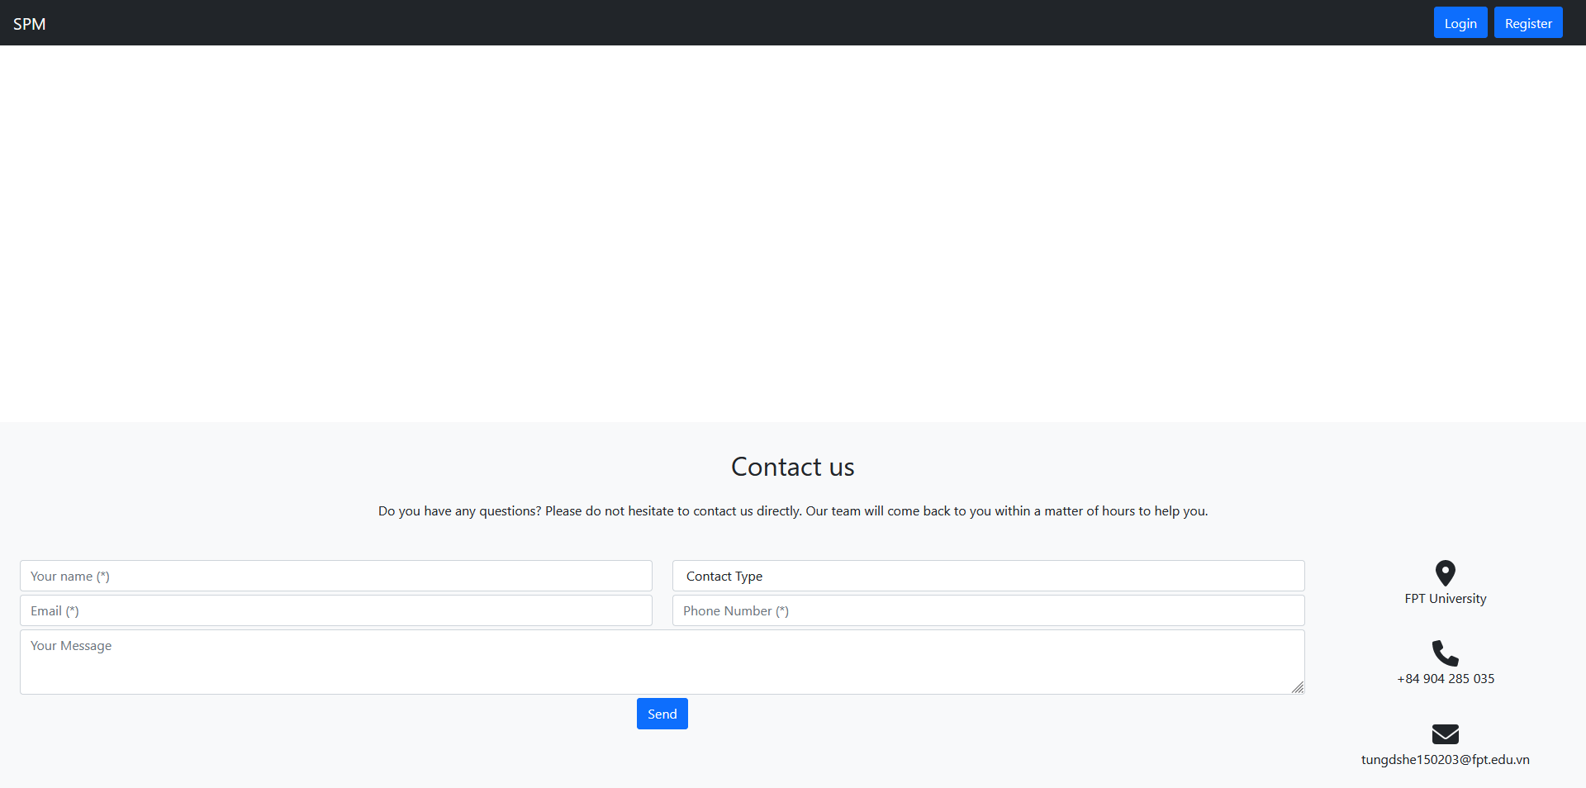

Web header:

* Before logged in:



* After logged in:



* Logged in and in Dashboard:



* User context menu:

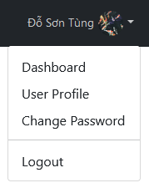

* Function details:

When the user first visits the site or when they log in/log out, they will be directed to this page.

## 2. User register:

* Function trigger: when user want to register an account
* Function description:
* Actor: User (admin, manager, trainer, student)
* Purpose: register a new account in system
* Interface:
* 3 text input field for email, full name, mobile
* 2 radio button for gender
* 1 button for submit
* Screen Layout:

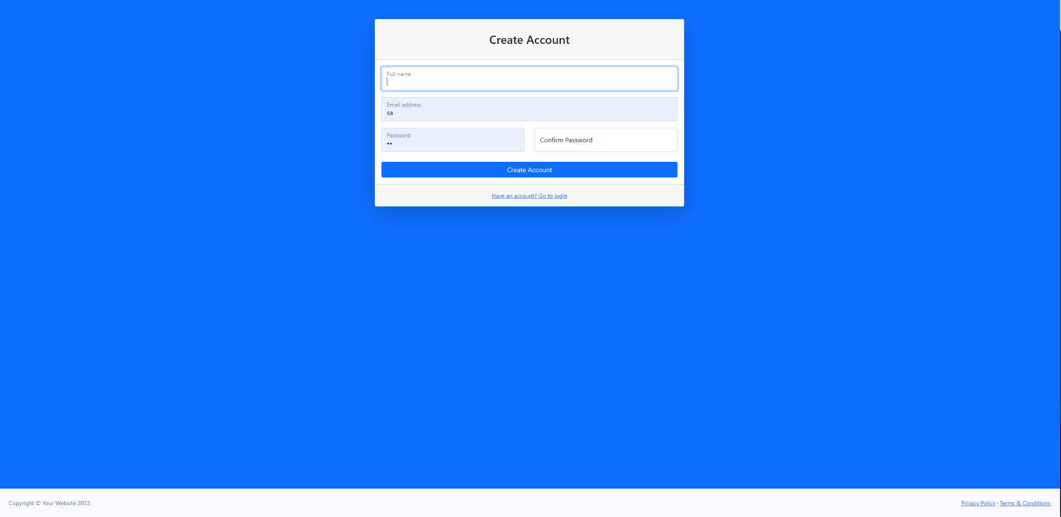

* Function details:

When enter to “User Registration” screen, user can enter their information to register a new account. After that, User can use this account to login in system.

## 3. User login:

● Function trigger: users access this screen by clicking "Login" from the default screen when accessing the website or accessing from the registration screen when clicking "Already have an account? Sign in instead" .

● Function description: Anyone can access this login screen, the purpose is to classify the user's role, giving the user access to the content that is allowed to access.

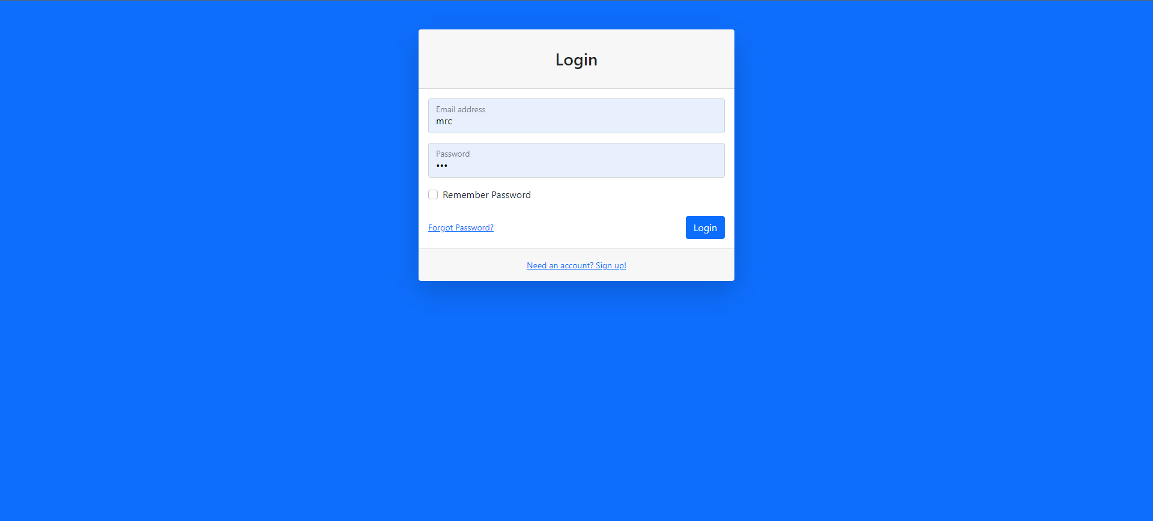

● Function Details: This screen has an email input field, a password input field, an optional input field to save login information, and a submit button used to send the entered information to the system. The system will compare the user's email and password with the data in the database. In case of matching, the user will be directed to the dashboard page corresponding to the role. In case the information does not match, the system will redirect the user back to the login screen with the message "Account or password is incorrect" or "This account has not been activated". In addition, users can also navigate back to the home screen by clicking on the logo or request a password reset via the "Forget password" link or navigate to the registration screen via the "Need for an account" link. ?Create an account".

## 4. Dashboard:

* Function trigger: When users with admin privilege want to access dashboard page.
* Function description:
* Actor: Admin
* Purpose: A dashboard to access other Admin’s function.
* Screen layout:

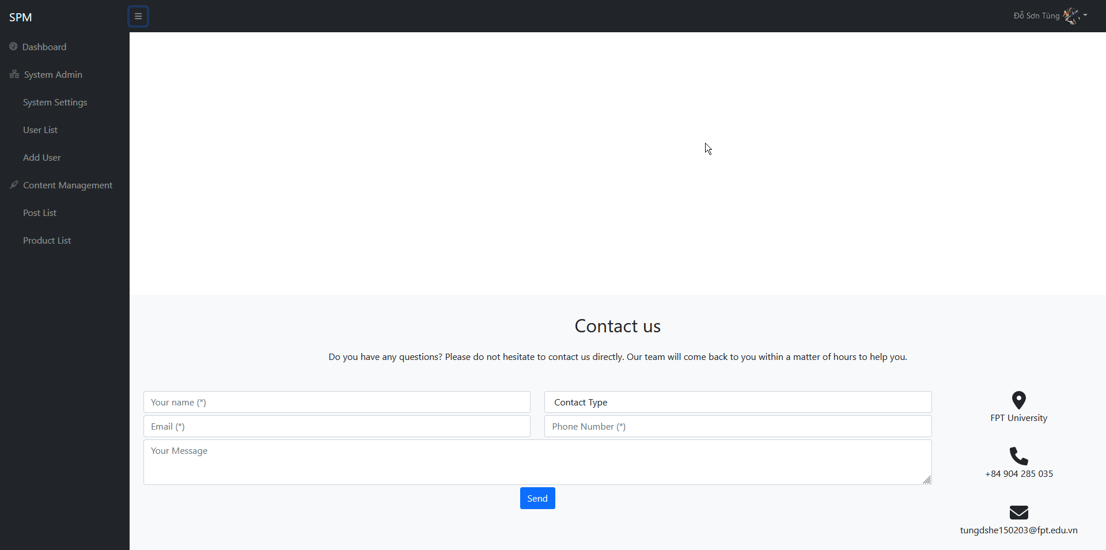

Sider menu:

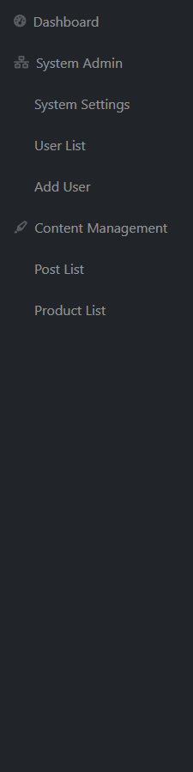

Web footer:

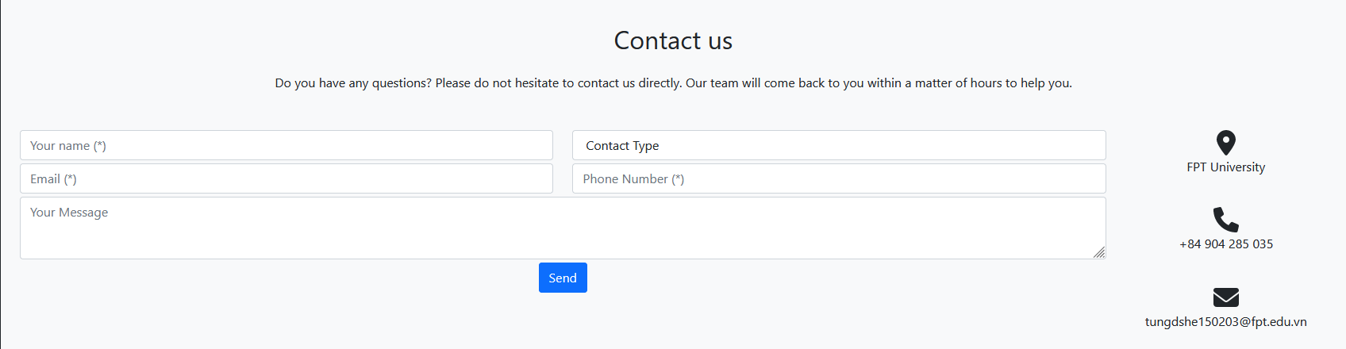

* Function details:

After users with admin privilege logged in, they can click on the user context menu to access the dashboard page.

## 5. Setting Management:

### 5.1 Setting List

* Function trigger: When Admin open setting list page (Click on System Setting on DashBroad)
* Function description:
* Actor: Admin
* Purpose: Allow Admin view setting list
* Interface:

+ 1 text input field to input name

+ 1 radio button for status (active, inactive)

+ 1 dropdown for group

+ 1 table to display list of user

+ 2 button to search by Status or Name

+ 1 button to change Status

+ 1 button Edit to access Setting details function

+ 2 button Next and Back to Paginate

* Screen Layout:

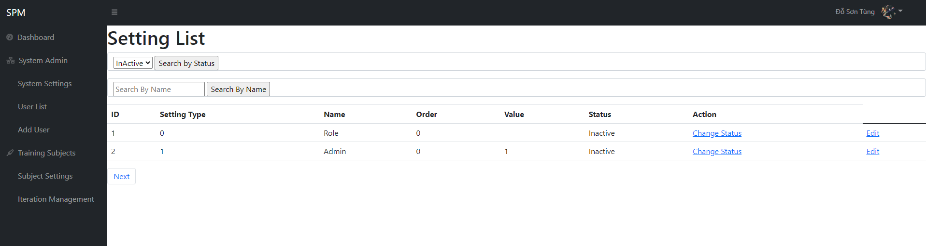

* Function details: Admin can search by Name, Filter by status, view the list after pagination and sorted by Id, display all setting list in database and filter by id, choose to edit setting detail or change status.

### 5.2 Setting Details:

* Function trigger: when user want to view and edit setting details
* Function description:
* Actor: User (admin, manager, trainer, student)
* Purpose: edit setting details in system
* Interface:
* 3 text input field for order, name, value
* 2 radio button for status (active, inactive)
* 1 dropdown for group
* 1 textarea for description
* 1 button for submit
* Screen Layout:

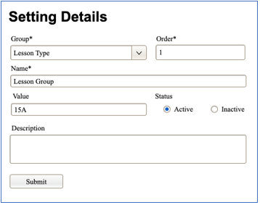

* Function details:

When enter a setting in the setting list table, the setting details screen will open and the user can view or edit information of the setting.

## 6. Subject Management:

### 6.1 Subject List

* Function Trigger: When user with Admin, Manager access dashboard screen and access Subject List screen from Dashboard Sidebar.
* Function Description:
* Actor: User (admin, manager)
* Purpose: View list of subjects and update subjects status.
* Interface:
* 2 dropdown to filter list by Manager or Status
* 2 input field to input subject code, name
* 2 button to search for inputted subject code, name
* 1 table to display list of subjects
* 1 button to activate/deactivate subject
* 1 button to access Subject Details function
* 1 path to Add New Subject
* Screen Layout:
* 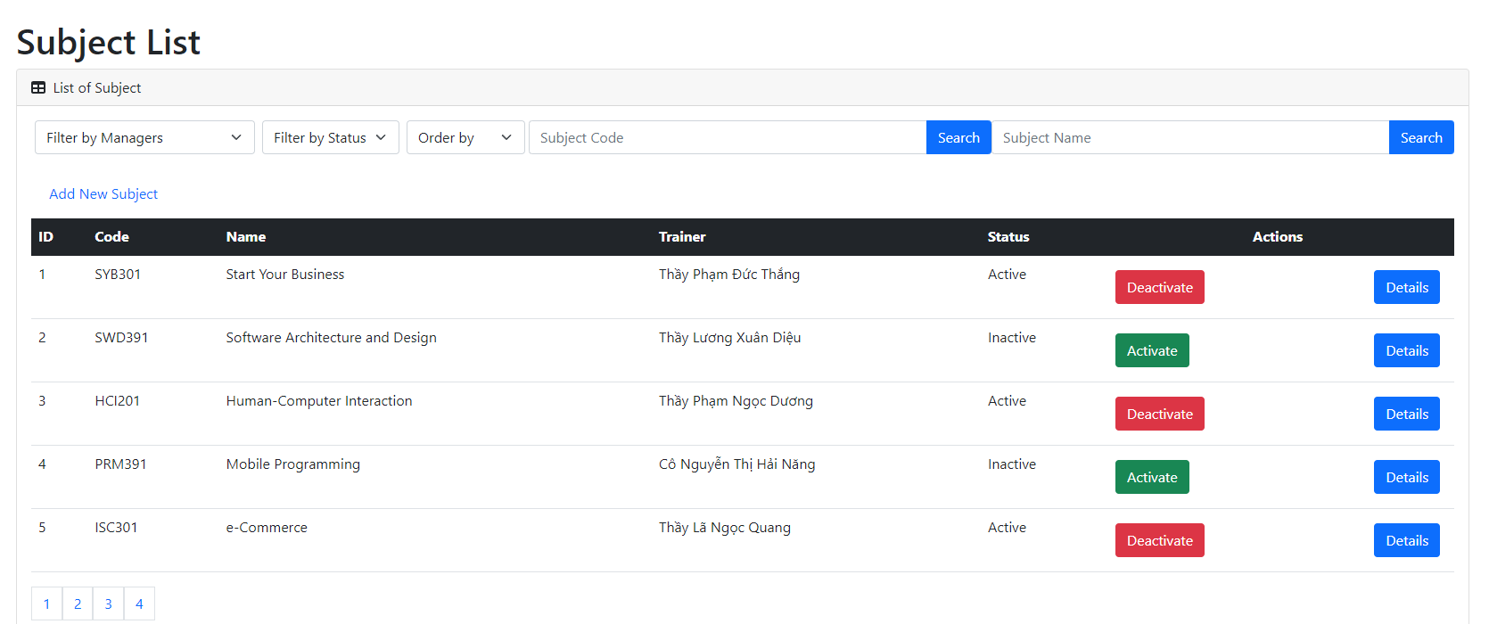
* Function Details:

When logged in as Admin or Manager, access the dashboard, then choose Subject Management on the sidebar, users can view and edit status of the subject. Admin, Manager also can filter the list by Manager or Status, or they can search for subject by name, or sort the list ascending or descending. The list of Subjects is paginated.

### 6.2 Subject Details

* Function Trigger: When user with Admin, Manager access dashboard screen and access Subject List screen from Dashboard Sidebar then click “Details” button on the row of the subject they want to view the details of.
* Function Description
* Actor: User (admin, manager)
* Purpose: View and edit details of the subject.
* Interface:
* 2 text input to edit subject code, name
* 1 number input to id of manager
* 2 checkbox to check status of the subject
* 1 textarea to enter subject description
* 1 submit button
* Screen Layout
* 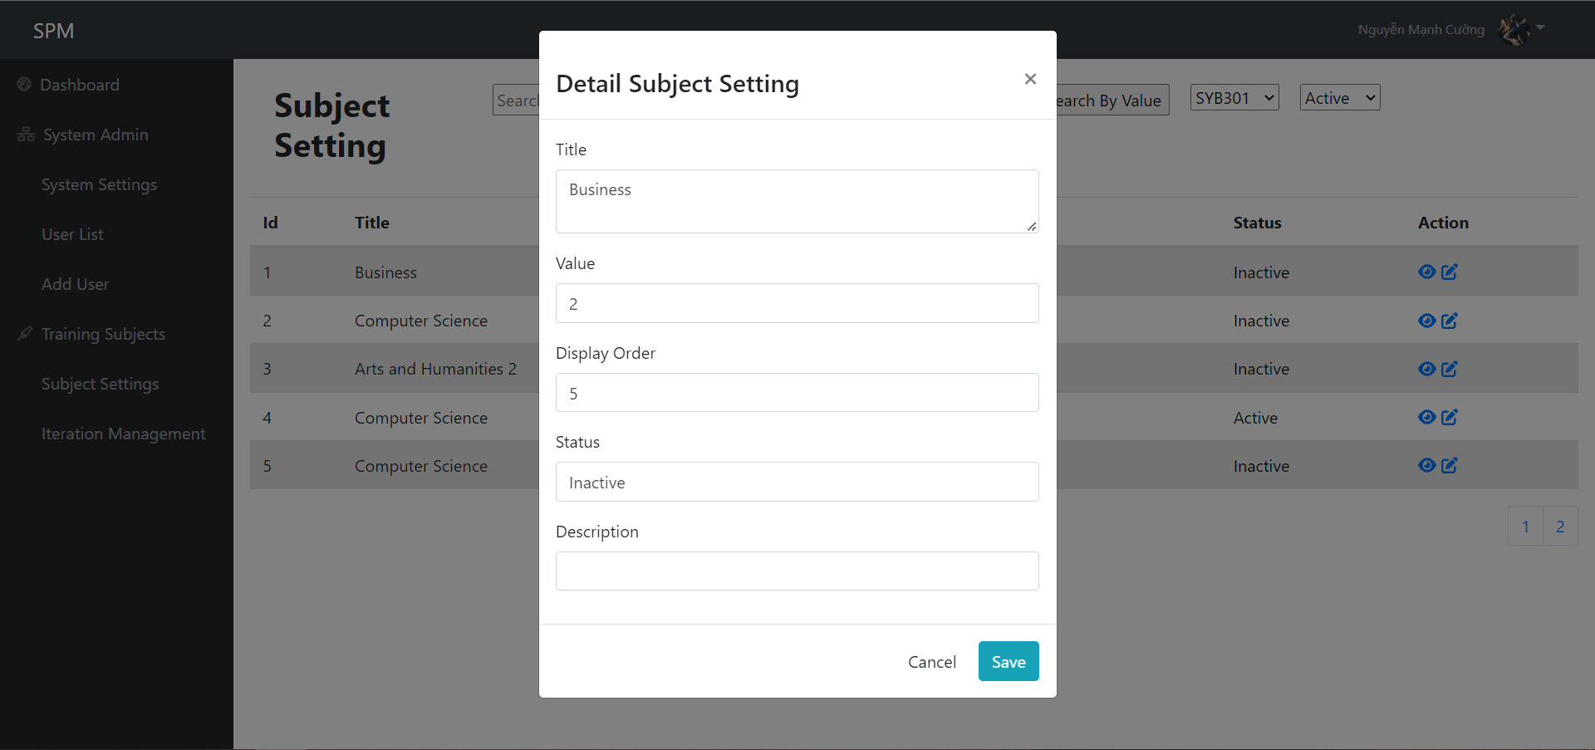
* Function Details

After logged in as Admin or Manager, then access the dashboard, access the Subject List screen and click the button to view details of the subject, users can edit name, code of subject, id of manager, change status and edit description of subject.

## 7. Iteration Management:

### 7.1 Iteration List

* Function Trigger: When user with Admin, Manager or Trainer access dashboard screen and access Iteration List screen from Dashboard Sidebar.
* Function Description
* Actor: User (admin, manager, trainer)
* Purpose: View list of iterations and update iteration status.
* Interface:
* 2 dropdown to filter list by Subject or Status
* 1 input field to input iteration name
* 1 button to search for inputted iteration name
* 1 table to display list of iterations
* 1 button to activate/deactivate iteration
* 1 button to access Iteration Details function
* 1 button to create new Iteration
* Screen Layout
* As Admin and Manager:

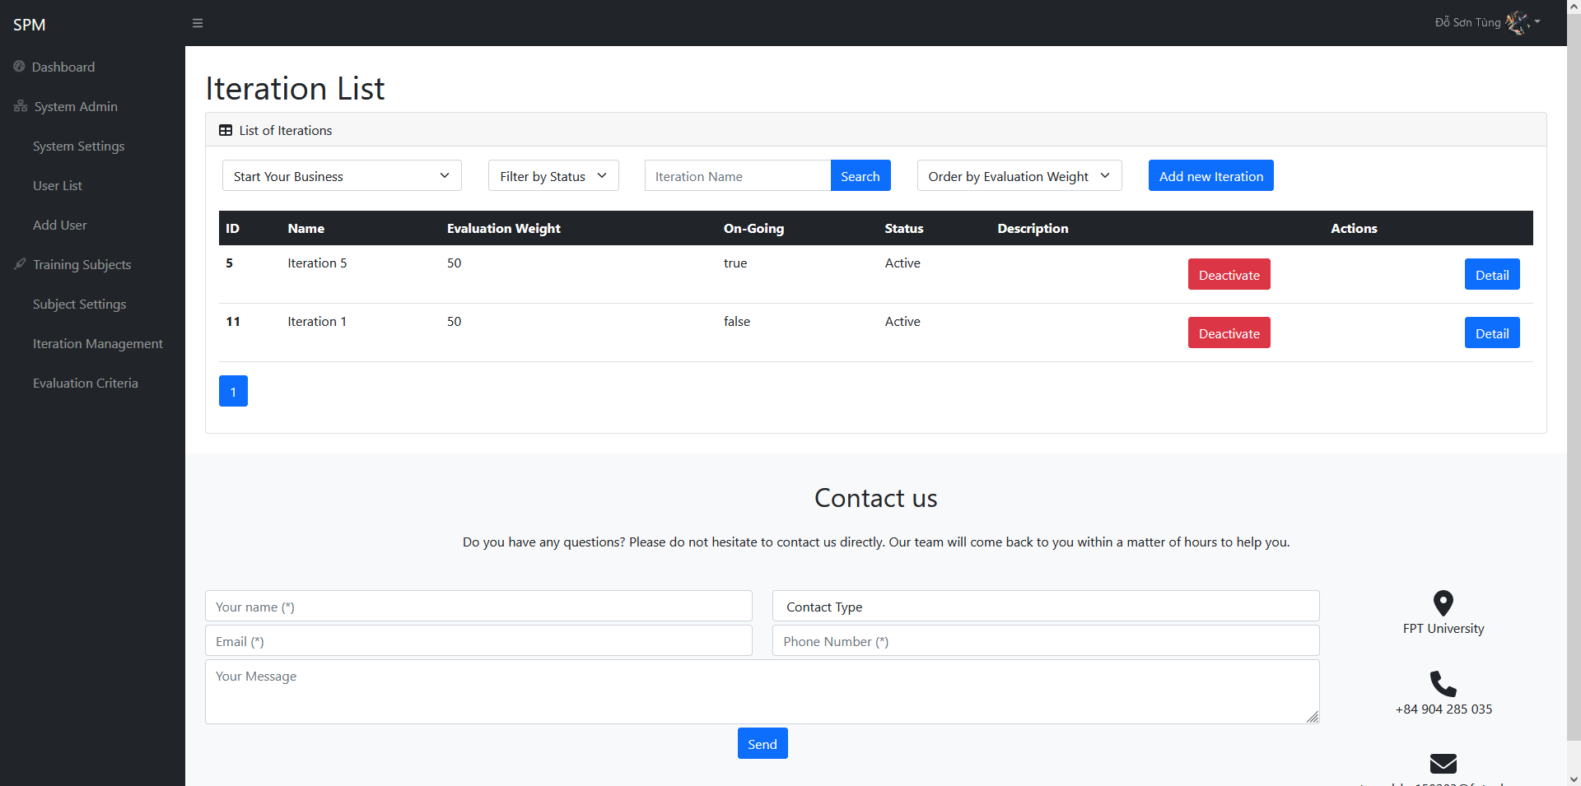

* As Trainer

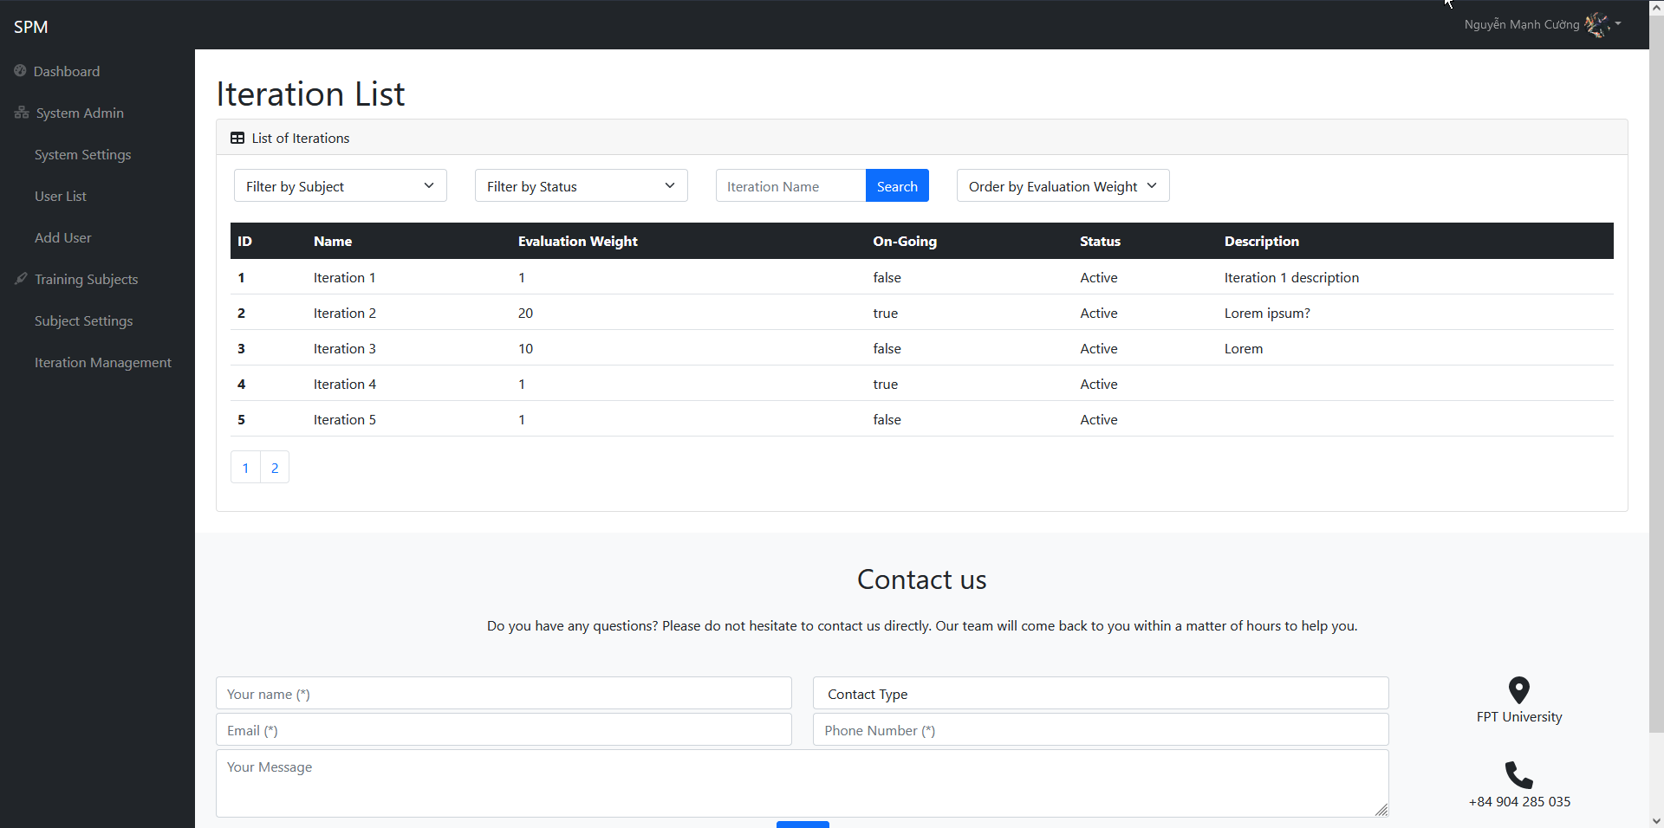

* Add new Iteration Screen

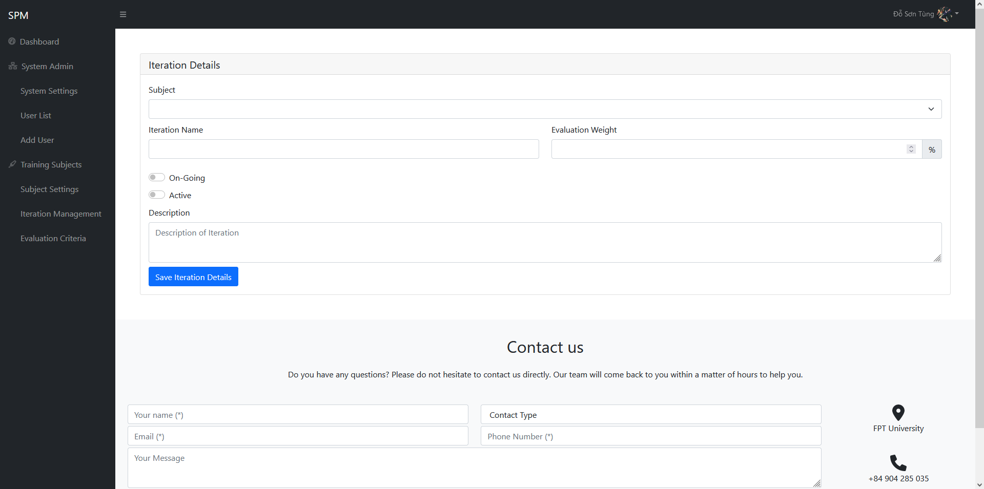

* Function Details:

When logged in as Admin or Manager, access the dashboard, then choose Iteration Management on the sidebar, users can view and edit status of the iterations. Trainer is read-only and can only view iterations list. Admin, Manager and Trainer can filter the list by Subject or Status, or they can search for iteration by name, or sort the list by evaluation weight ascending or descending. The list of Iterations is paginated.

### 7.2 Iteration Details

* Function Trigger: When user with Admin, Manager or Trainer access dashboard screen and access Iteration List screen from Dashboard Sidebar then click “Detail” button on the row of the iteration they want to view the details of.
* Function Description
* Actor: User (admin, manager)
* Purpose: View and edit details of the iteration.
* Interface:
* 1 dropdown to select the subject of the iteration
* 1 input to edit iteration name
* 1 number input to enter iteration evaluation weight
* 2 checkbox to enable/disable ongoing and status of the iteration
* 1 textarea to enter iteration description
* 1 submit button
* Screen Layout

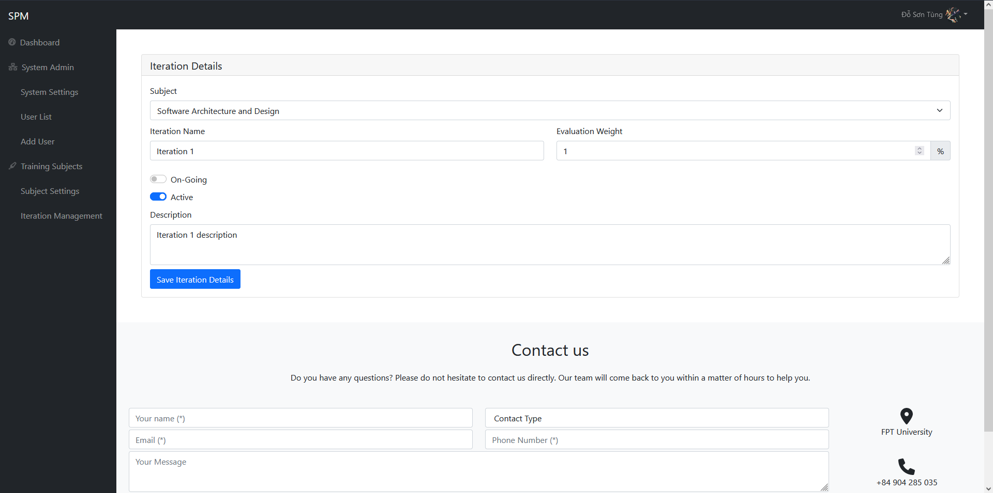

* Function Details

After logged in as Admin or Manager, then access the dashboard, access the Iteration List screen and click the button to view details of the iteration, users can then choose a subject from a list of available subjects, change evaluation weight from a range of 1 to 100, change ongoing and status, edit iteration name, as well as the description of the iteration.

## 8. User Profile:

* Function Trigger:

When a user wants to see their profile, they can choose the avatar icon in the top right of the website and choose “User Profile”. The system will redirect to the User Profile screen for users.

* Function Description:
* Actor: User (admin, manager, trainer, student)
* Purpose: Viewtheir user profile.
* Interface:
* 3 input to show and edit information
* 1 submit button
* Screen Layout:

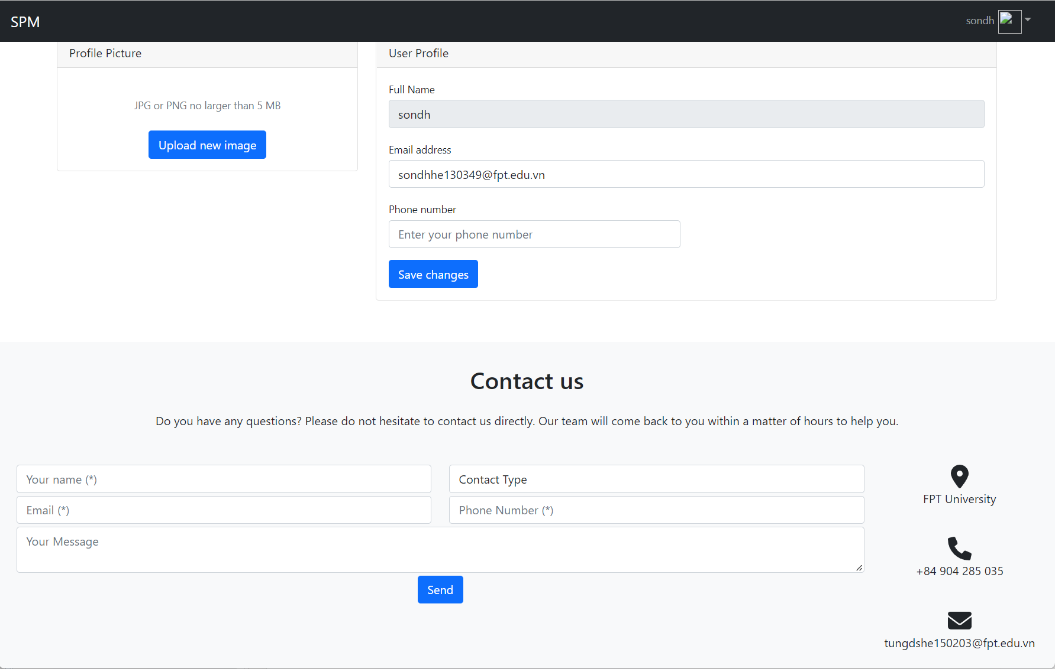

* Function Details:

After login to the system, the user can click to the top right in the header. After that, the user can see an option “User Profile”. Click to this option, the system will redirect to the User Profile screen. In this screen, users can see their information like full name, email and phone number. Users also can change their information and update to the system.

## 9. Change password:

* Function Trigger:

When a user wants to change their password, they can choose the avatar icon in the top right of the website and choose “Change password”. The system will redirect to the Change Password screen for users.

* Function Description:
* Actor: User (admin, manager, trainer, student)
* Purpose: change the password for user
* Interface:
* 3 input for enter password (current, new, confirm)
* 1 submit button
* Screen Layout:

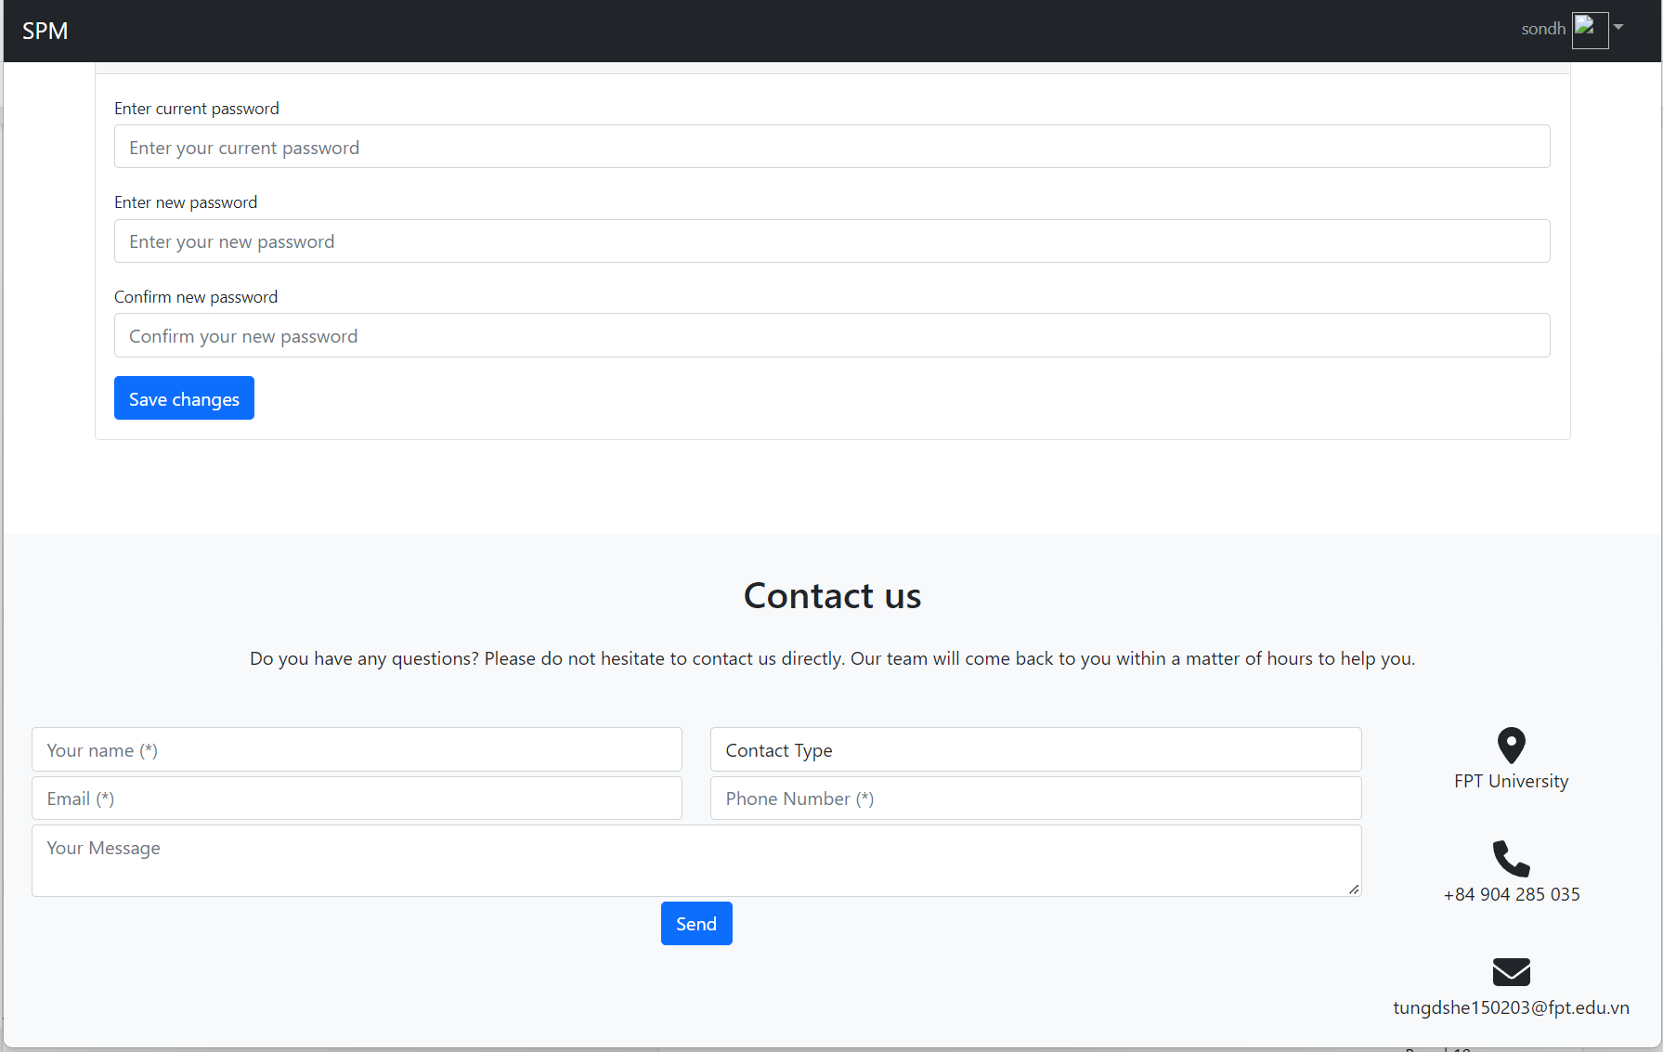

* Function Detail:

After login to the system, the user can click to the top right in the header. After that, the user can see an option “Change password”. Click to this option, the system will redirect to the Change Password screen. In this screen, users can change their password if they don’t want to use their current password.

## 10. User Management:

### 10.1 User List

* Function Trigger: When Admin access dashboard screen and access User List screen from Dashboard Sidebar.

·

* Function Description:

- Actor: Admin

- Purpose: View list of user, access user details to edit and update user status.

- Interface:

+ 2 dropdown to filter list by Role or Status

+ 1 input field to input email name

+ 1 button to search for inputted email

+ 1 table to display list of user

+ 1 button to activate/deactivate user status

+ 1 button to access User Details function

+ 2 button Next and Back to Paginate

·

Screen Layout

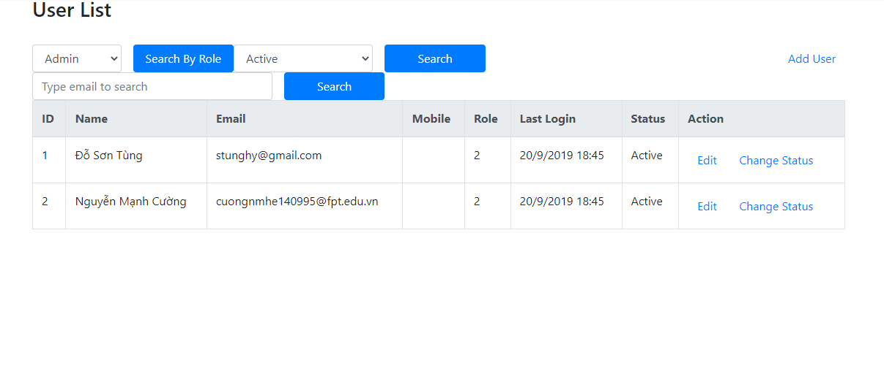

·

* Function details: Admin can search by email, Filter by status, view the list after pagination and sorted by Id, choose to edit user detail or change status.

### 10.2 User Details

* Function Trigger: When Admin access dashboard screen and access User List screen from Dashboard Sidebar then click “Edit” button on the row of the user they want to view the details of.
* Function Description:

- Actor: Admin

- Purpose: View and edit details of the user.

- Interface:

+ 2 dropdown to select the Role and Status of user.

+ 3 input field to input name, mobile, job position

+ 2 radio button to choose male/female

+ 1 button to save User detail

+ 1 card to display avatar

* Screen Layout:

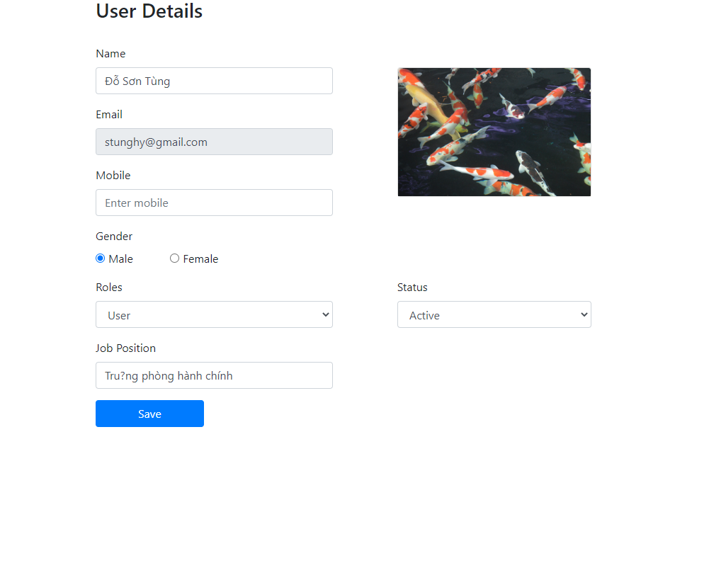

·

* Function details: Admin can edit detail of an user like role, status, name, moblie, job, gender

## 11. Subject Setting:

### 11.1 Subject Setting List:

* Function Trigger: When user with Admin, Manager access dashboard screen and access Subject Setting screen from Dashboard Sidebar.
* Function Description:
* Actor: User (admin, manager)
* Purpose: View list of subjects and update subjects status.
* Interface:
* 2 dropdown to filter list by Title or Status
* 1 input field to input subject title
* 1 button to search for inputted subject title
* 1 input field to input subject value
* 1 button to search for inputted subject value
* 1 table to display list of subjects
* 1 button to view subject detail
* 1 button to edit subject detail
* Screen Layout:
* 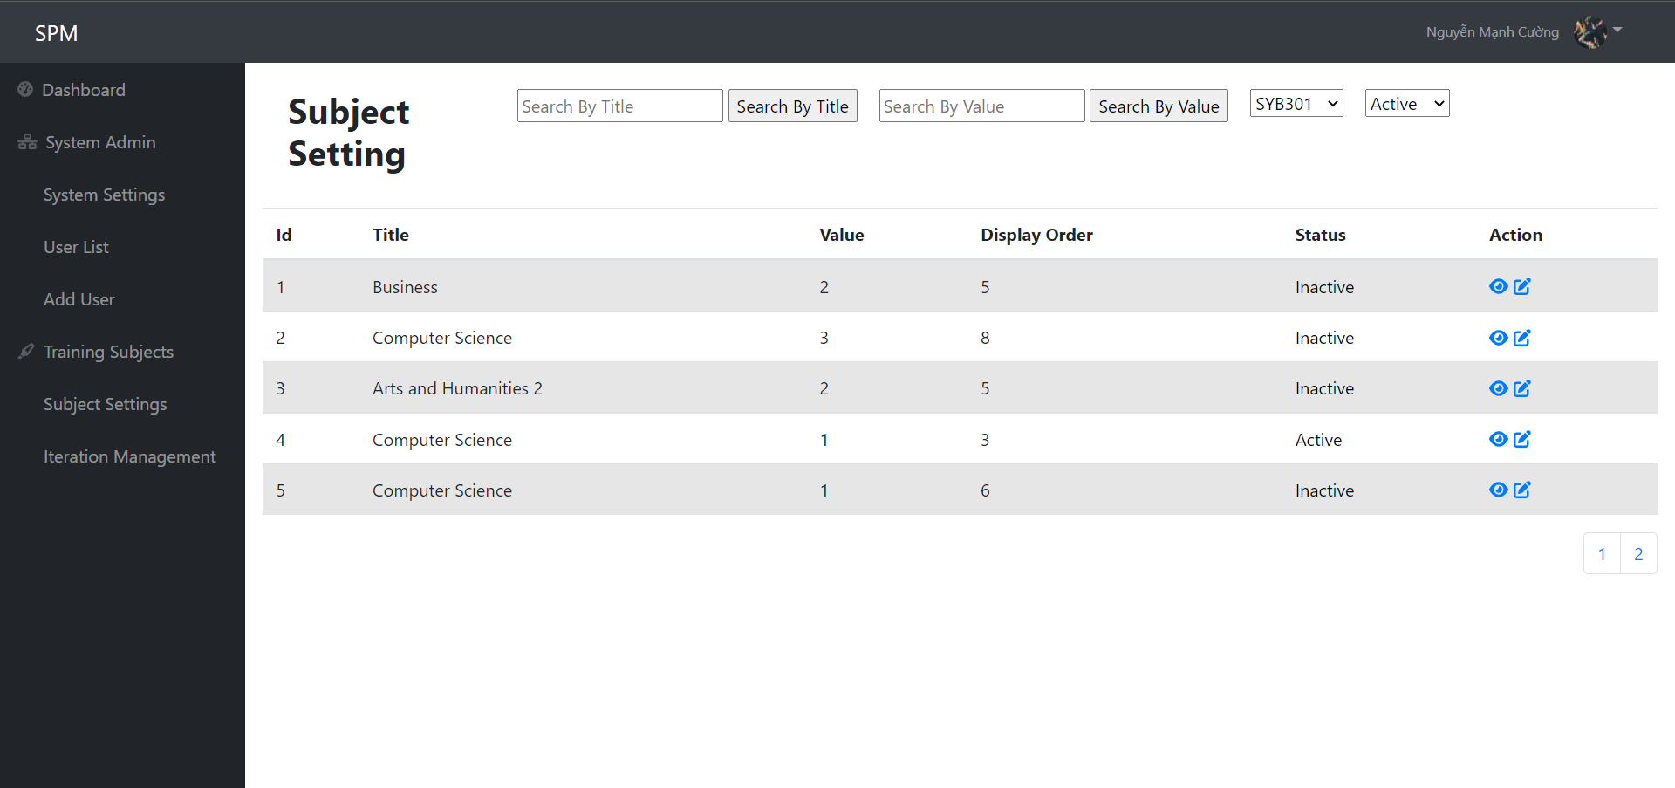
* Function Details:

When logged in as Admin or Manager, access the dashboard, then choose Subject Setting on the sidebar, users can view and edit search the subject. Admin, Manager also can filter the list by Title or Status, or they can search for subject by Title, or sort the list ascending or descending. The list of Subjects is paginated.

### 11.2 Subject Details

* Function Trigger: When user with Admin, Manager access dashboard screen and access Subject Setting screen from Dashboard Sidebar then click “view” button or “edit” button on the row of the subject they want to view the details of.
* Function Description
* Actor: User (admin, manager)
* Purpose: View and edit details of the subject.
* Interface:
* 1 text input to edit subject title
* 1 number input to edit subject value
* 1 number input to edit subject display order
* 1 checkbox to check status of the subject
* 1 textarea to enter subject description
* 1 save button
* Screen Layout
* 
* Function Details

After logged in as Admin or Manager, then access the dashboard, access the Subject Setting screen and click the button to view details or edit subject, users can edit Title, value, display order of subject, change status and edit description of subject.

## 12. User Authorization

* Function Trigger: Every time users access a link.
* Function Description:
* Actor: Users (Admin, Manager, Trainer, Student), Guests.
* Purpose: Prevent users from accessing unauthorized links.
* Interface: none
* Screen Layout:
* Access forbidden screen

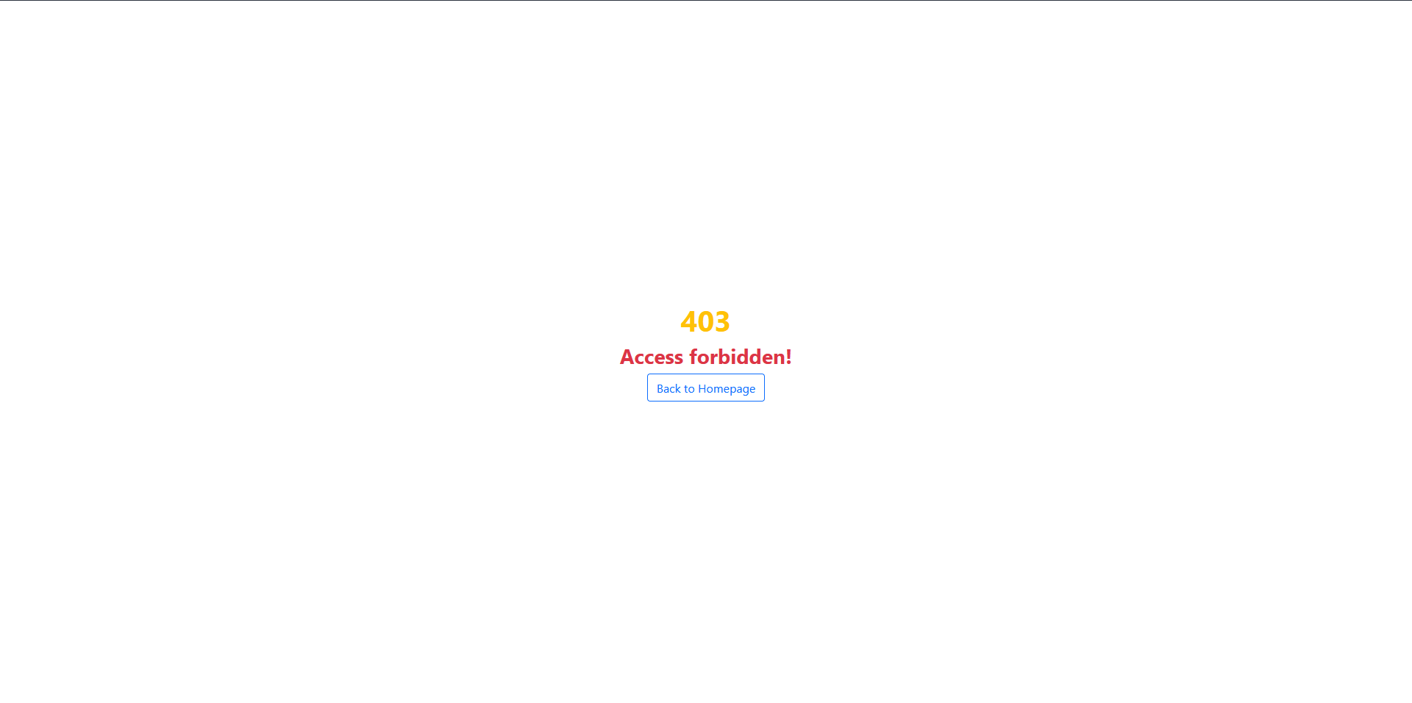

* Function Details: This function includes front end as well as back end code. In front end code, certain elements will be hidden from the user without proper authorization. In the back end code, every time users access a link, they will be checked for proper authorization before granting accessibility.

## 13. Criteria Management

### 13.1. Criteria List

* Function Trigger: When user with Admin, Manager or Trainer access dashboard screen and access Criteria List screen from Dashboard Sidebar.
* Function Description:
* Actor: Users (Admin, Manager, Trainer)
* Purpose: Allow users to view/edit/create evaluation criteria.
* Interface: Dropdown list allow users to filter criteria, as well as searching by name and sorting by evaluation weight and a button to add new criteria.
* Screen Layout:
* Criteria List Screen

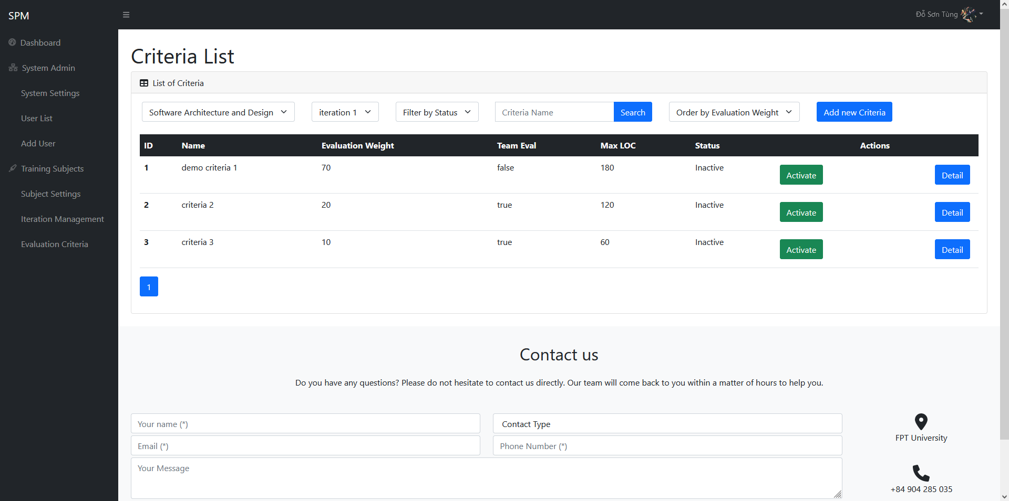

* Add new criteria screen

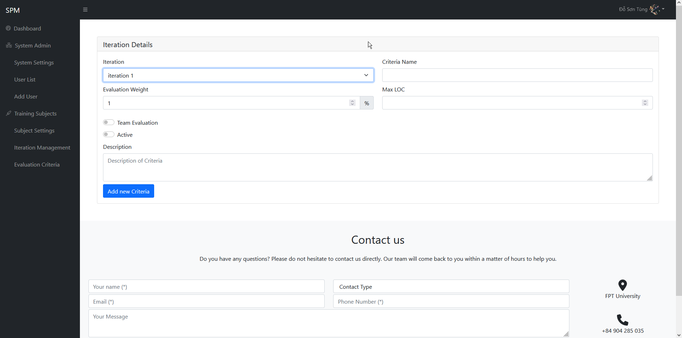

* Function Description: After logged in, users with Admin/Manager/Trainer role can click the “Criteria List” to access this screen. This screen includes a table that display a list of criteria filtered by subject id and iteration id. Users can optionally choose to filter further by status or search by name. Admin and Manager can also add new criteria.

### 13.2. Criteria Details

* Function Trigger: When users with Admin / Manager click “Detail” button on the selected criteria, they will access this screen.
* Function Description:
* Actor: Users (Admin, Manager)
* Purpose: Allowing users to view and edit details of the selected criteria.
* Interface: A form contains the details of the selected criterias and a button to submit the changes.
* Screen Layout:

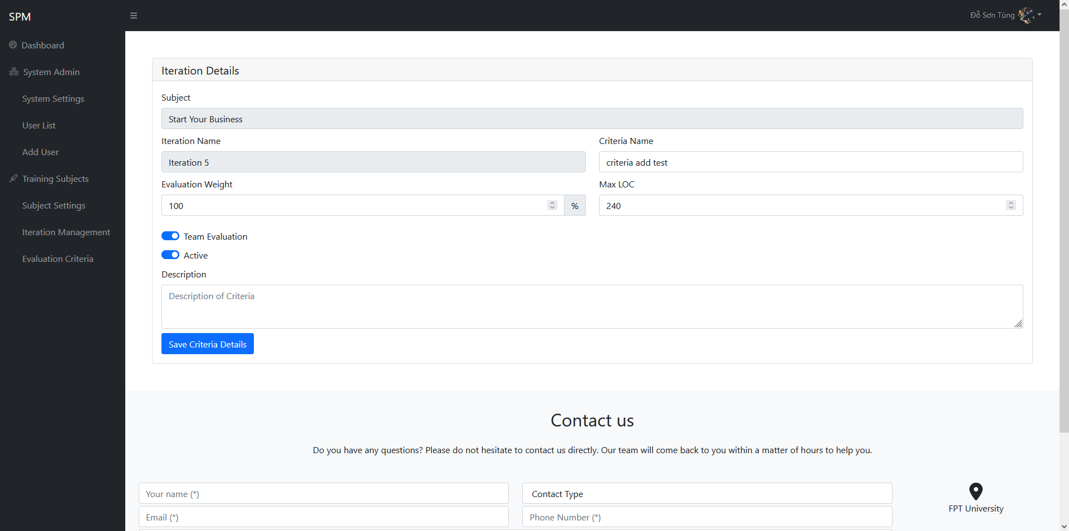

* Function Description: After users with Admin / Manager role click the “Details” button on the selected criteria, they will be directed to this screen. This screen consist of 2 disabled field to prevent users from changing the values, and the other details can be freely changed such as the name of the criteria, the evaluation weight, the max LOC, or the description, e.g….After changing the details they wanted, users can click “Save Criteria Details” and the data will be updated, then they will be redirected back to Criteria List.

## 14. Class Management

### 14.1. Class List

* Function Trigger: When user with Manager, Trainer access dashboard screen and access Class List screen from Dashboard Sidebar.
* Function Description:
* Actor: Users (Manager, Trainer)
* Purpose: Allow users to view/change status of class
* Interface: Dropdown list allow users to filter class by subject, trainer, term, status, as well as searching by code and sorting by class id
* Screen Layout:

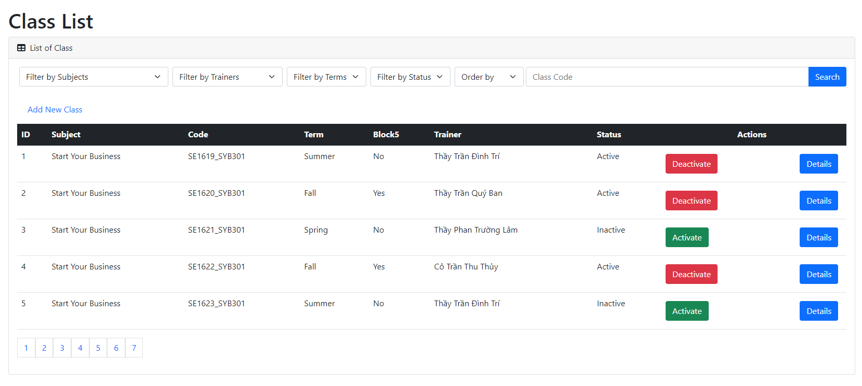

* Function Description: After logged in, users with Manager/Trainer role can click the “Class List” to access this screen. This screen includes a table that display a list of classes filtered by subject id, trainer id or term id. Users can optionally choose to filter further by status or search by class code.

### 14.2. Class Details

* Function Trigger: When users with Manager click “Detail” button on the selected class, they will access this screen.
* Function Description:
* Actor: Users (Manager)
* Purpose: Allowing users to view and edit details of the selected class.
* Interface: A form contains the details of the selected class and a button to submit the changes.
* Screen Layout:

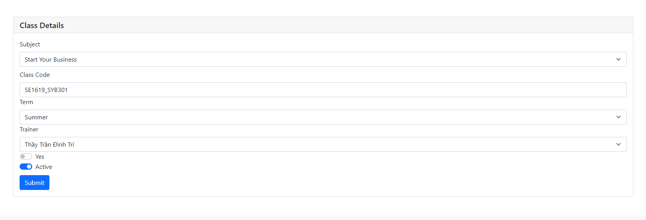

* Function Description: After logged in as Manager, then access the dashboard, access the Class List screen and click the button to view details of the class, users can edit name, code of class, term, trainer, change status block5, change status and edit description of subject.

## 15. Class Setting Management

### 15.1 Class Setting List

● Function trigger: After logging into the system, the User presses the “Class Setting List” option that collapses from the “Team” dropdown button on the left sidebar of the screen to access the function.

● Function description:

* Actor: Trainer
* Purpose: The screen above will display a list of class settings that the Trainer is in charge of, But Manager and Admin can view all. Here the user can search and filter class settings by class name, code and by team. Users can also edit or view class setting details.
* Interface:

+ 2 dropdown to filter list by Role or Status

+ 1 input field to input email name

+ 1 button to search for inputted email

+ 1 table to display list of user

+ 1 button to activate/deactivate user status

+ 1 button to access User Details function

+ 2 button Next and Back to Paginate

● Screen layout:

* Class Setting List:

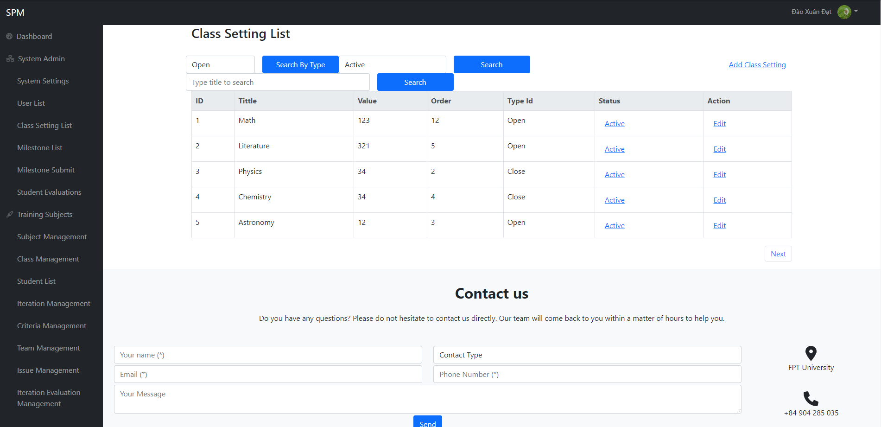

* Add Class Setting:

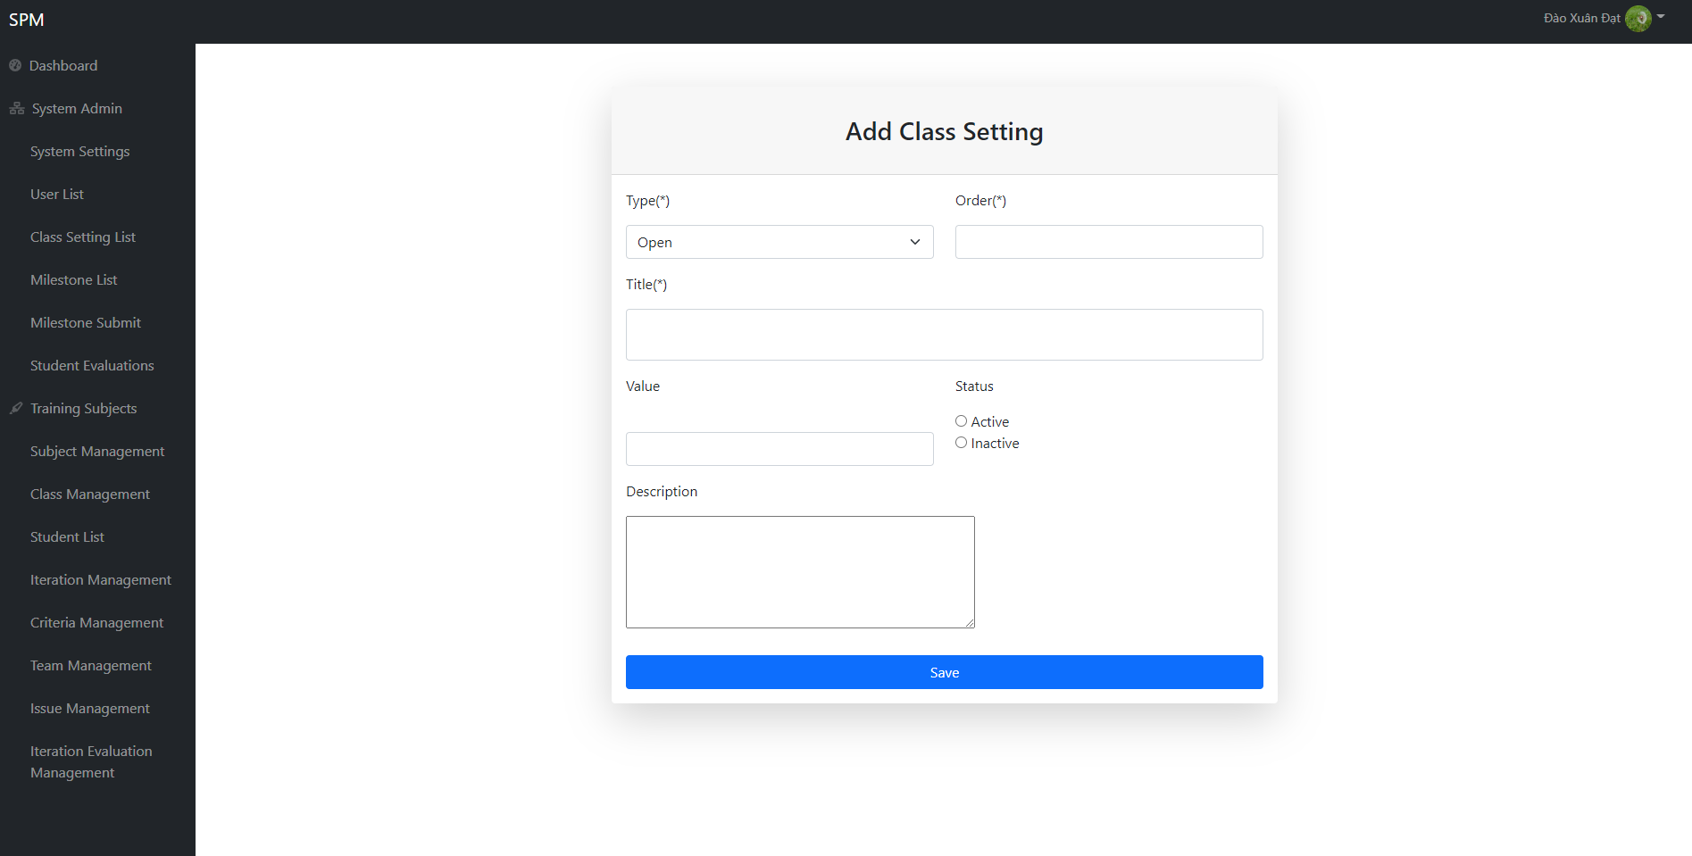

● Function Details: Users can search for class settings by name, filter classes by and by subject. Click the "Edit" button to view details and edit the class settings.

### 15.2 Class Setting Details

● Function trigger: At the "Class User List" screen, the user clicks on the "Edit" button for each class user on the right side to access the function.

● Function description:

* Actor: Trainer
* Purpose: The previous screen will show the details of the class setting. At this screen, the user will see the detailed information of the class setting, the user edits the information of the class setting and then clicks the "Save" button to complete the editing.
* Interface:
* 2 dropdown to select the Role and Status of user.

+ 3 input field to input Group, order, name, value, status, description

+ 2 radio button to choose male/female

+ 1 button to save User detail

● Screen layout:

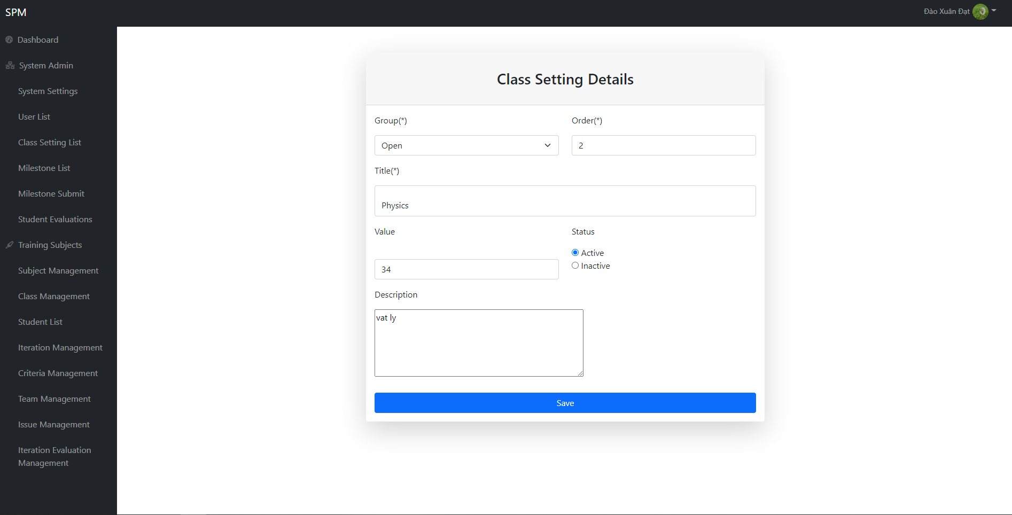

● Function Details: When the user updates the information of the class setting, the system will check the input, the Outdrop Date field will not be empty.

## 16. Milestone Management

### 16.1. Milestone List

● Function trigger: After logging into the system, the user presses the Milestone option on the left sidebar of the screen to access the function.

● Function description: The above screen will display a list of milestones. Here users can search, filter and sort milestones by title, type setting, value, order. Add new, change status, edit or view milestone details.

* Actor: Trainer
* Purpose: The above screen will display a list of milestones. Here users can search, filter and sort milestones by title, type setting, value, order. Add new, change status, edit or view milestone details.
* Interface:

● Screen layout:

* Milestone List

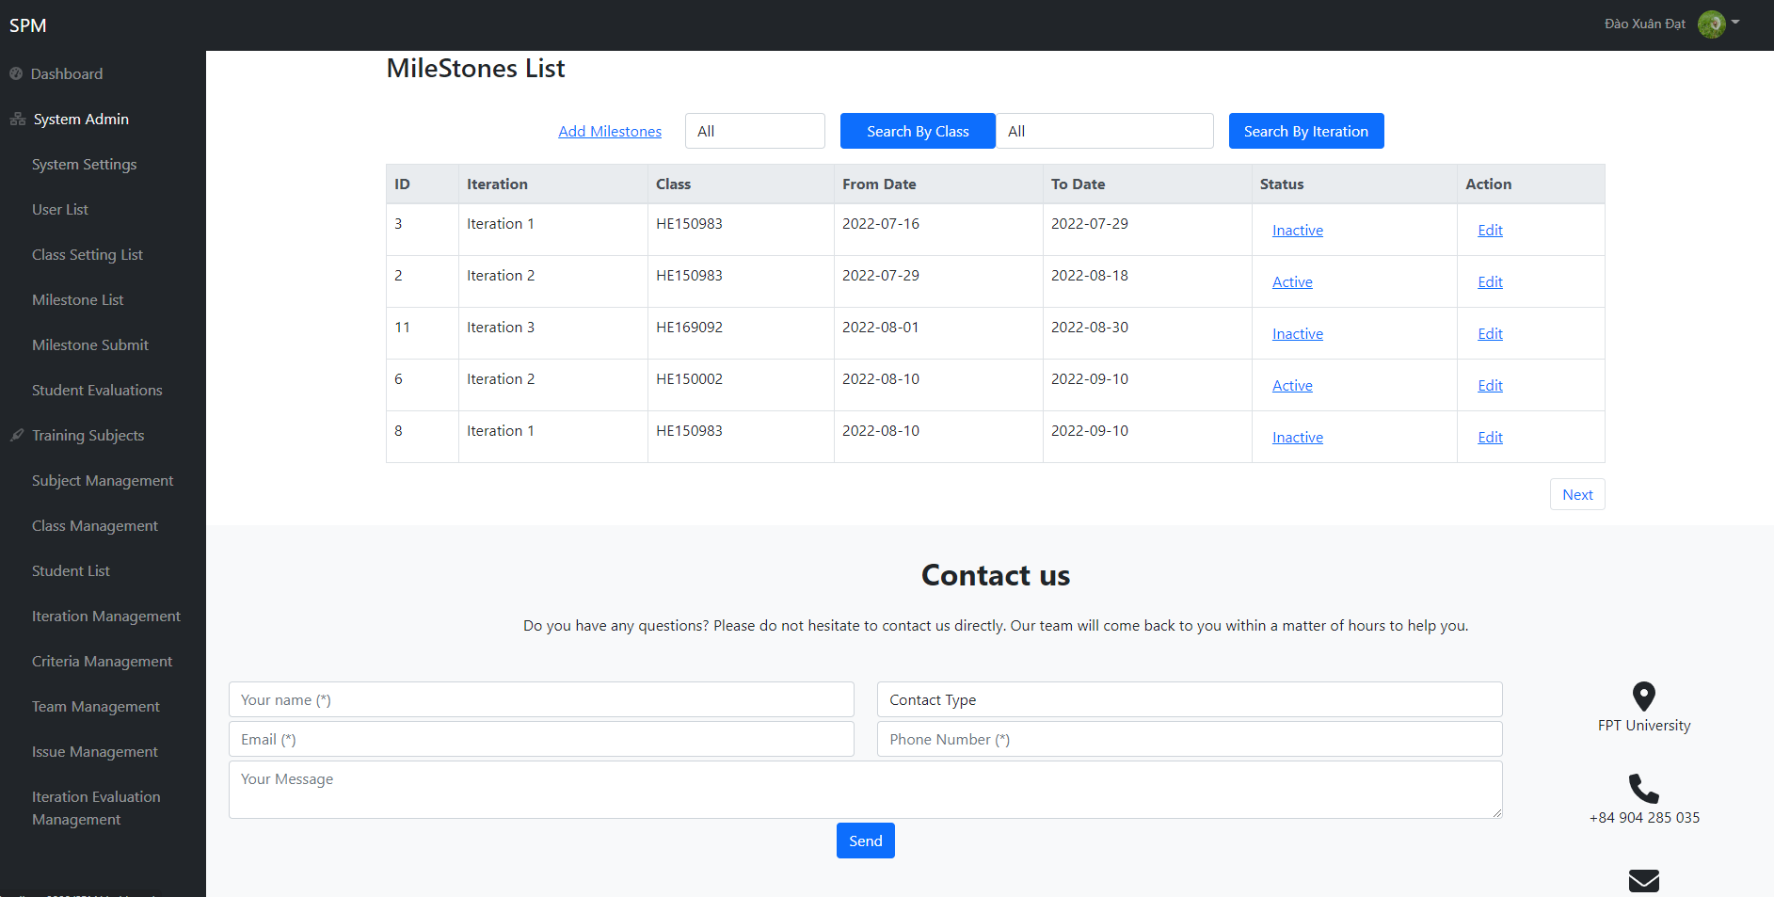

* Add Milestone List:

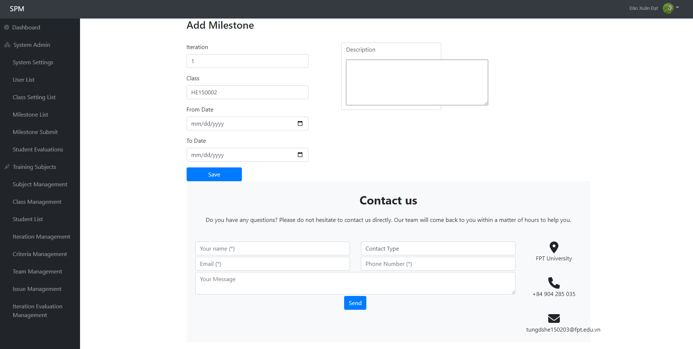

● Function Details: Users can search milestones by title, filter milestones by class, status, sort by name, from date, to date. Click "+ Create" button to create a new milestone, click "Edit" button to view milestone details and edit, click "Open"/"Closed"/"Cancelled" button to quickly change milestone status .

### 16.2. Milestone Details

● Function trigger: At the Milestone List screen, the user clicks the "Edit" button for each milestone on the right side to access the functionality.

● Function description:

* Actor: Trainer
* Purpose: At this screen, the user will see the details of the milestone, the user edits the information of the milestone then presses the "Save" button to complete the editing.
* Interface:
* 2 dropdown to select the Role and Status of user.

+ 3 input field to input Iteration, Class and Description

+ 2 form to choose From Date and To Date

+ 1 button to save Milestone detail

● Screen layout:

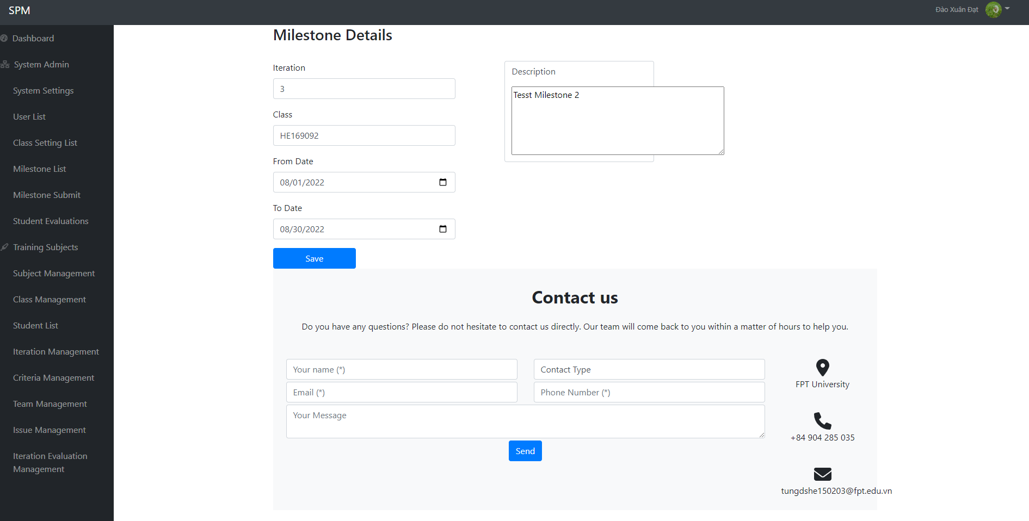

● Function Details: When the user updates the information of the milestone, the system will check the input, the fields marked with * will not be empty, to date must be greater than from date.

### 16.3 Milestone Submits

● Function trigger: After logging into the system, the user presses the Milestone Submits option on the left sidebar of the screen to access the function.

● Function description:

* Actor: Student
* Purpose: At this screen, the user will see the details of the milestone, the user edits the status of the milestone, Student can commit, submit, fix evaluating then presses the "Save" button to complete the editing.
* Interface:
* 2 drop down list to choose filter by team or milestone
* 4 expand the text area to see the status of commit, submit, fix and evaluate for criteria.
* Save button for each of grading comment for Criteria_name

● Screen layout:

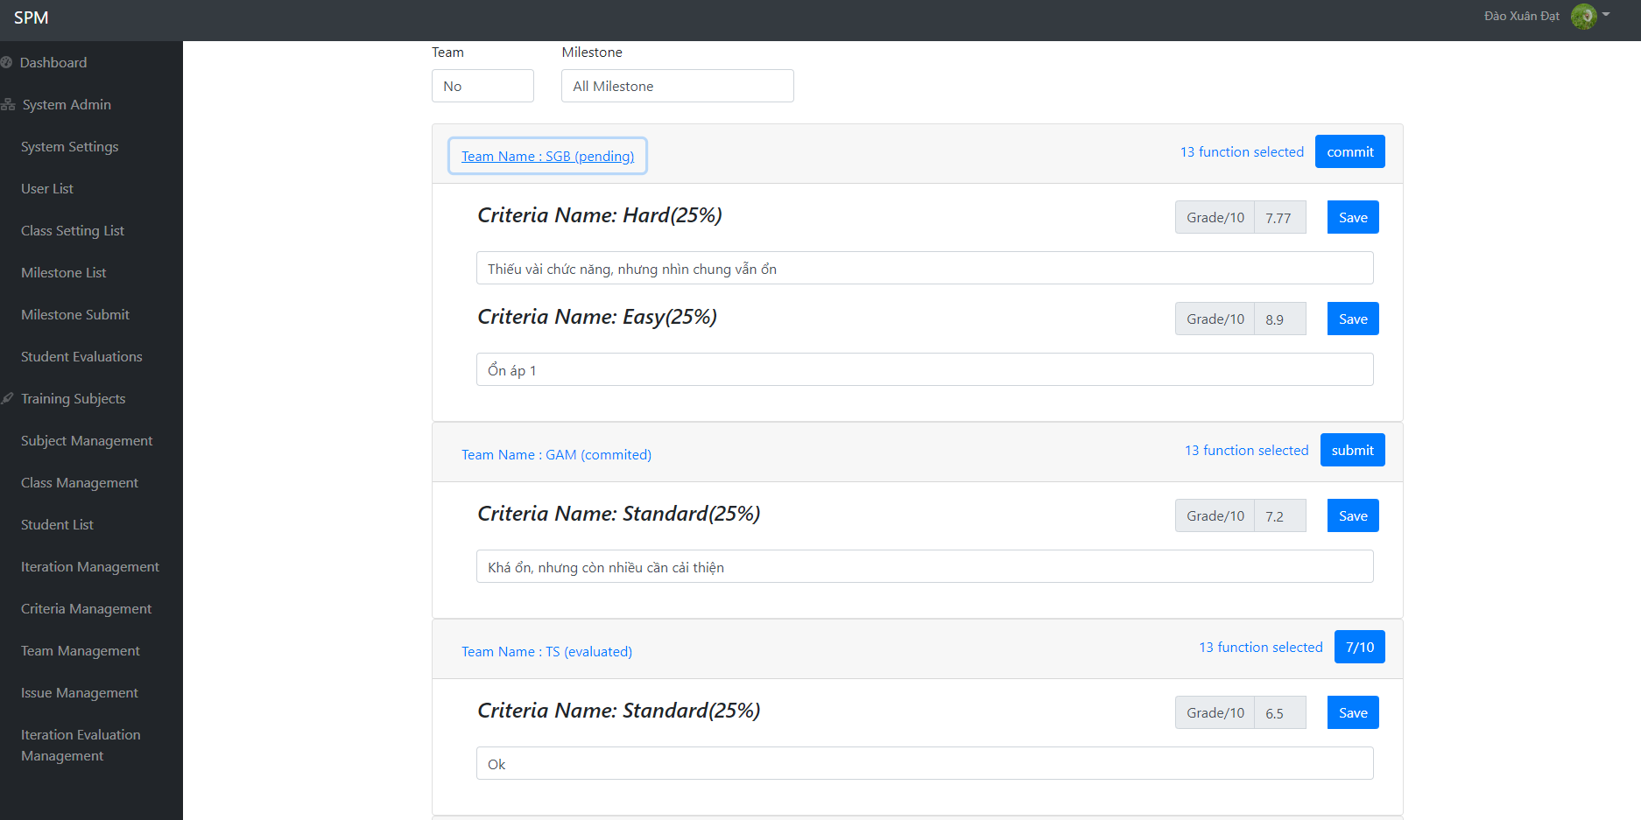

● Function Details: When the user updates the information of the milestone, the system will check the input, the fields marked with * will not be empty, to date must be greater than from date.

## 17. Student Evaluation

● Function trigger: After logging into the system, the user presses the Student Grades option on the left sidebar of the screen to access the function.

● Function description:

* Actor: User (admin, manager)
* Purpose: View details of all the Evaluation.
* Interface:
* 2 tab for user choose to view Evaluation or LOC evaluation
* 1 label to see total evaluation.
* 2 drop down list to see detail of Team and Individual evaluation
* 1 textarea to see LOC evaluation
* 1 Table to see details of LOC evaluation.
* 1 save button

● Screen layout:

* Student Evaluation:

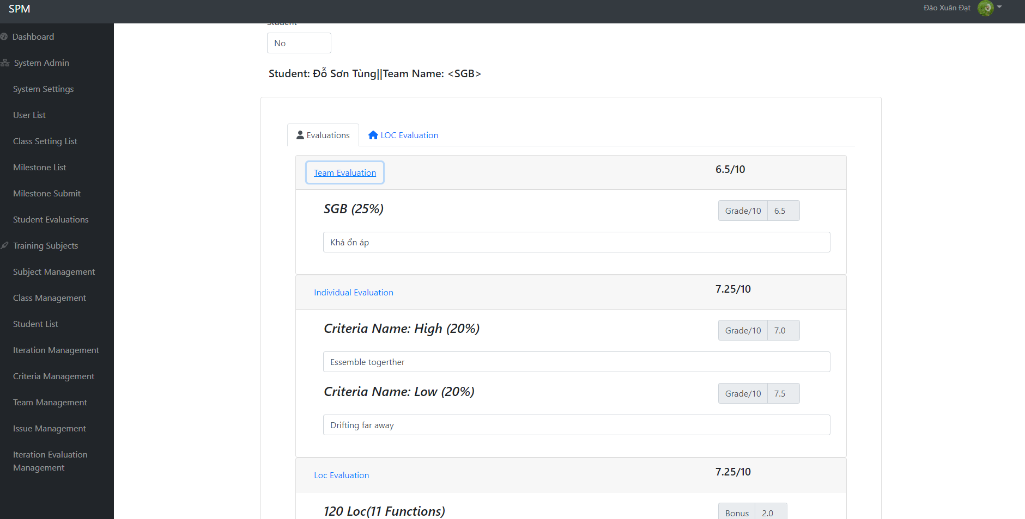

* Student LOC Evaluation:

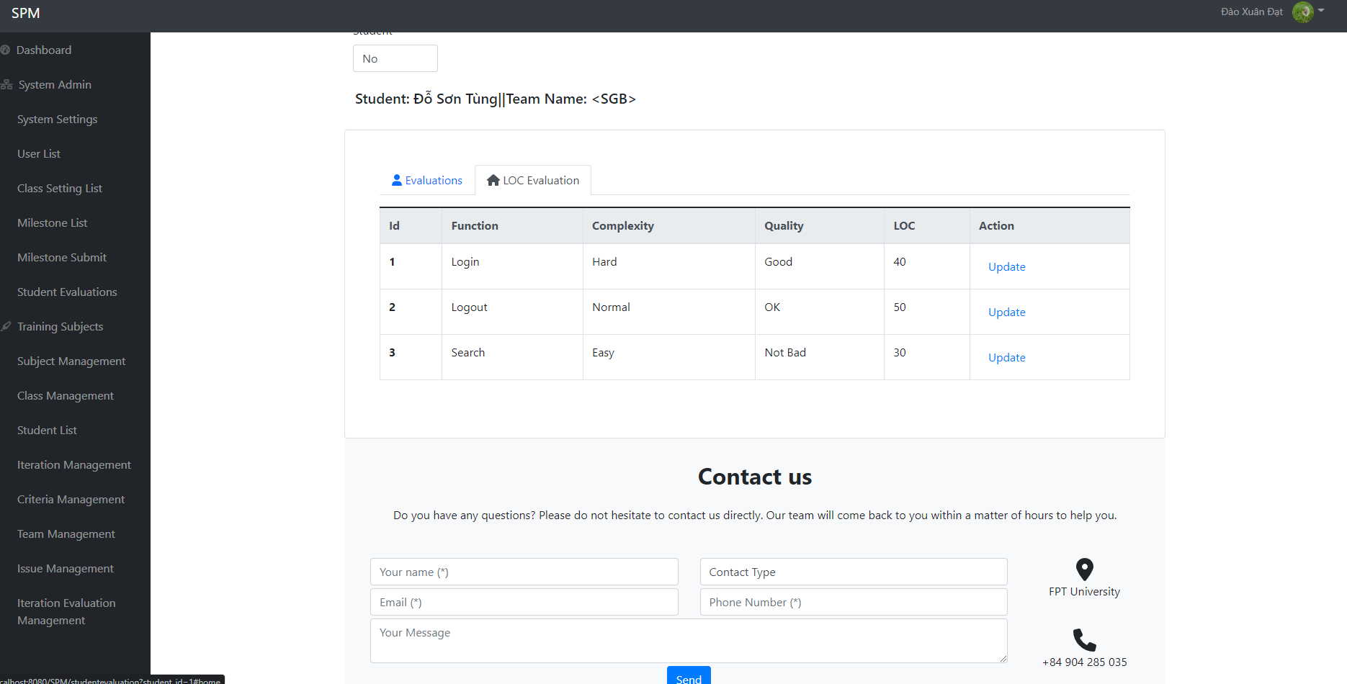

● Function Details: At this screen, the user will see the details of the evaluation include Total, team, individual and LOC evaluation. The user can choose the LOC evaluation tab to see the details of LOC evaluation.

## 18. Issue Management

### 18.1. Issue List

* Function Trigger: When user with Student, Trainer access dashboard screen and access Issue List screen from Dashboard Sidebar.
* Function Description:
* Actor: Users (Student, Trainer)
* Purpose: Allow users to view/change status of issue
* Interface: Dropdown list allow users to filter issue by team, type, function, milestone, assignee, status as well as searching by title, sync issue and sorting by issue id
* Screen Layout:

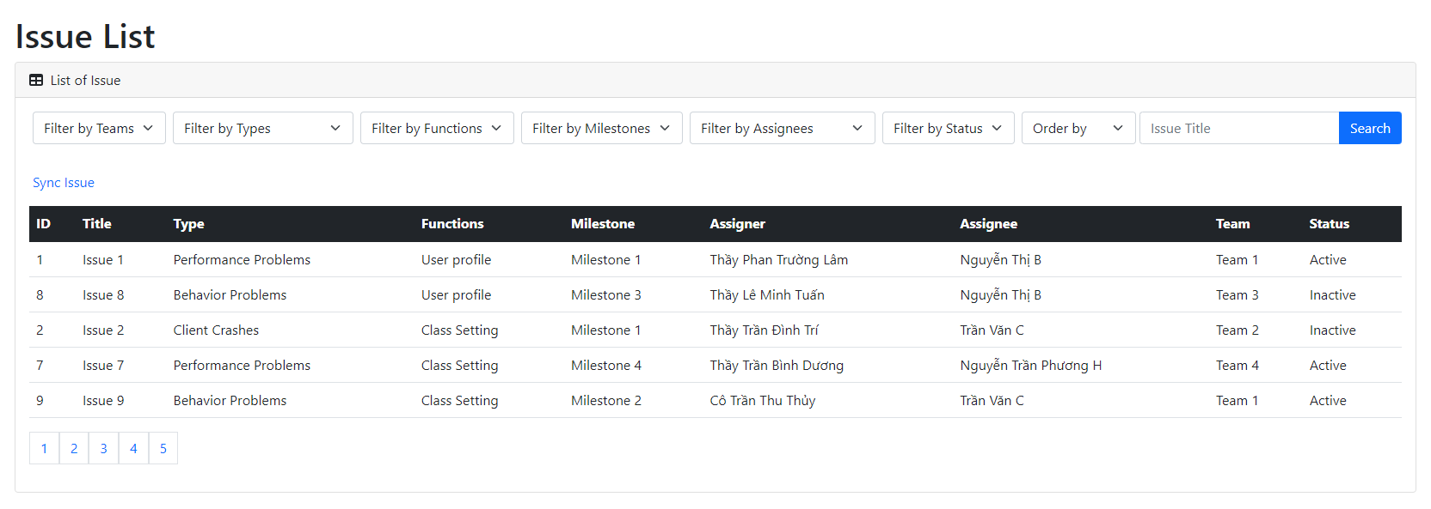

* Function Description: After logged in, users with Student/Trainer role can click the “Issue List” to access this screen. This screen includes a table that display a list of issues filtered by team, type, function, milestone, assignee, status. Users can optionally choose to filter further by status or search by issue title.

### 18.2. Issue Sync

* Function Trigger: When users with Trainer click “Sync” button on the selected issue, they will perform function.
* Function Description:
* Actor: Users (Manager)
* Purpose: Accept data synchronisation with GitLab.
* Interface:
* Screen Layout:
* Function Description: After logged in as Trainer, then access the dashboard, access the Issue List screen and click the button to sync issue.

## 19. Iteration Evaluation

● Function trigger: After logging into the system, the user presses the Iteration Grades option on the left sidebar of the screen to access the function.

● Function description:

* Actor: User (Trainer)
* Purpose: View details of all the Evaluation of iteration.
* Interface:
* 2 dropdown to filter by team or milestone.
* 1 label to input number of iteration.
* 1 button to import evaluation.
* 1 Table to see details of iteration evaluation.
* 1 save button.

● Screen layout:

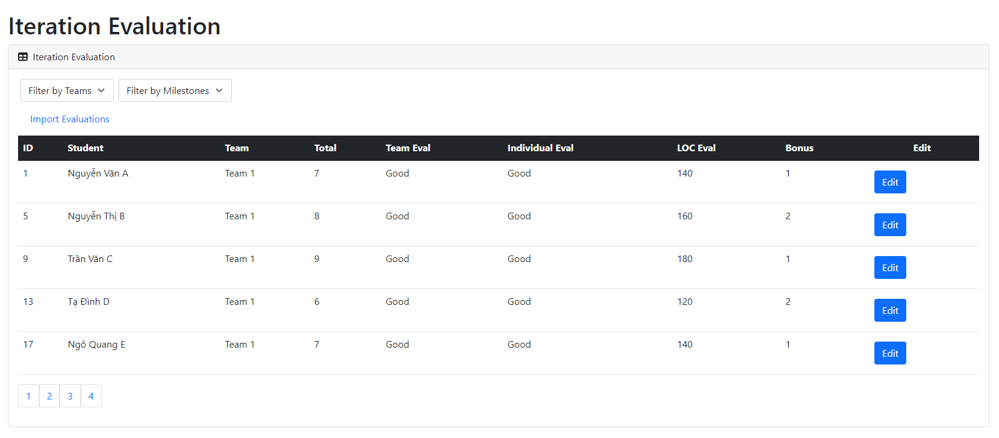

● Function Details: At this screen, the user will see the details of the evaluation include roll number, student name, team, total, team eval, individual eval, LOC eval, bonus. And select the Edit button in the edit column to edit the information of the table.

## 20. Tracking Update

* Function Trigger: When user logged in and click “Update evaluated function” in the navbar.
* Function Description:
* Actor: Users (Admin, Manager, Trainer, User)
* Purpose: Allow users to create/edit/view updates for evaluated function.
* Interface: A list to show update records and a form to edit/add new update.
* Screen Layout:
* Choose function you want to update.

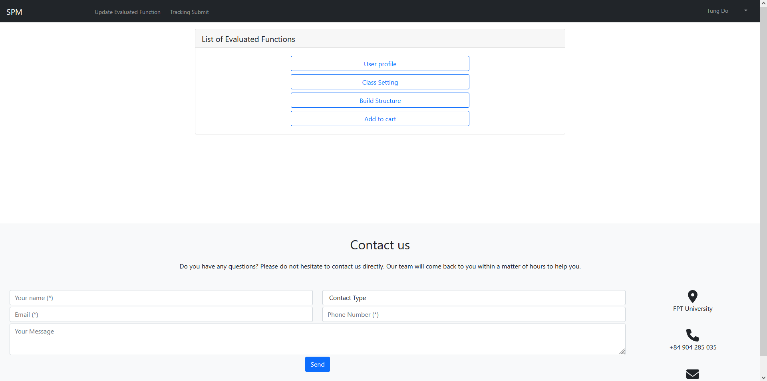

* Main Tracking update screen

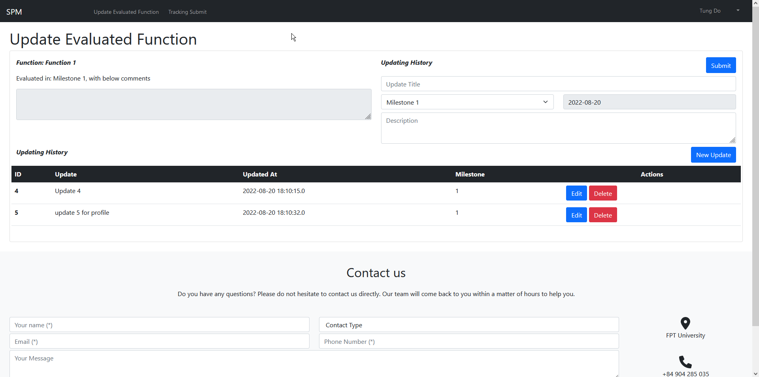

* Function Description: When user logged in and click “Update evaluated function” in the navbar, user will see a list of functions they can choose to update. After clicking that function, they will be sent to a screen to view and create/update/delete the update records for that function.

## 21. Tracking Submit

* Function Trigger: When user logged in and click “Tracking Submit” in the navbar.
* Function Description:
* Actor: Users (Admin, Manager, Trainer, User)
* Purpose: Allow users to submit their functions.
* Interface: A list to show update records and allow user to submit selected functions.
* Screen Layout:
* Choose iteration containing the function you want to submit:

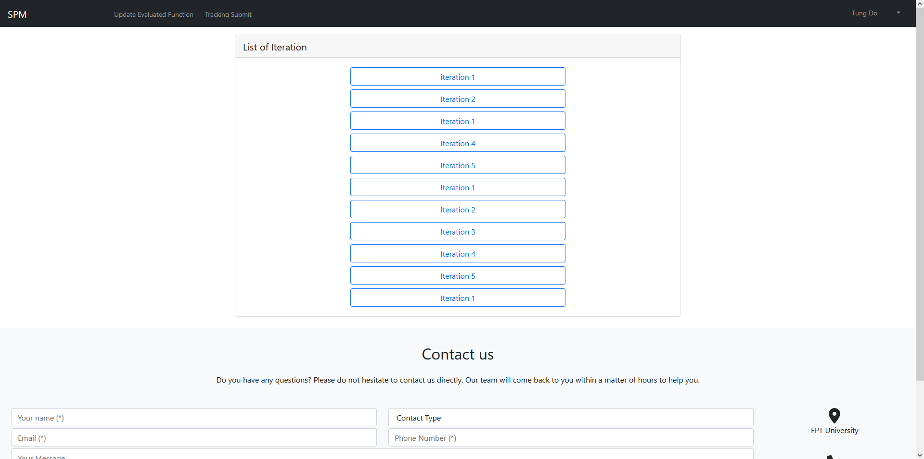

* Main Tracking Submits screen

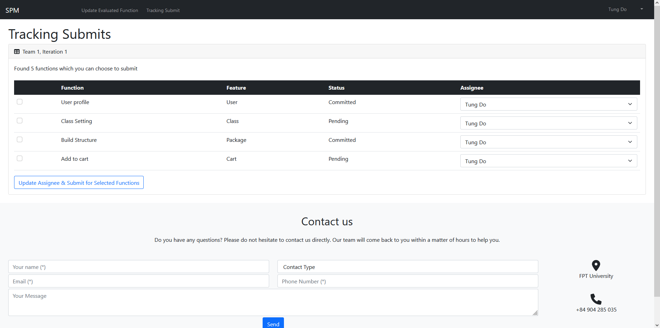

* Function Description: When user logged in and click “Tracking Submit”, they will be shown a list of iterations, from which you can choose to to submit the functions from. At the main tracking submit screen, user can use the checkboxes to select which functions they want to update, as well as to assign the function to someone else.

## 22. Team List:

* Function Trigger: When the trainer wants to see or update the list of information about the teams that have registered for the project
* Function Description:
* Actor: trainer
* Purpose: show, update list of information about the teams
* Interface:
* 1 table to show list data
* 2 button for edit and show detail
* 1 field for search
* Screen Layout:

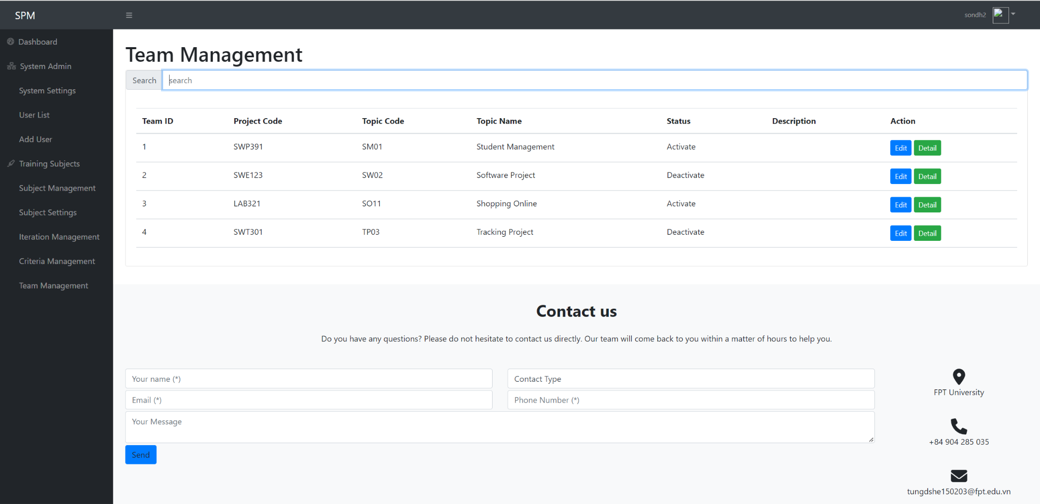

* Function Detai: When the trainer wants to view or edit the list of information about the groups that have registered for the project, they can access the Dashboard, then select "Team Management". The system will navigate to the project team management page.

## 23. Team Detail:

* Function Trigger: When the trainer wants to see the list of information about the teams that have registered for the project
* Function Description:
* Actor: Trainer
* Purpose: show detail team project
* Interface:
* 6 input field to show information of team project
* Screen Layout:

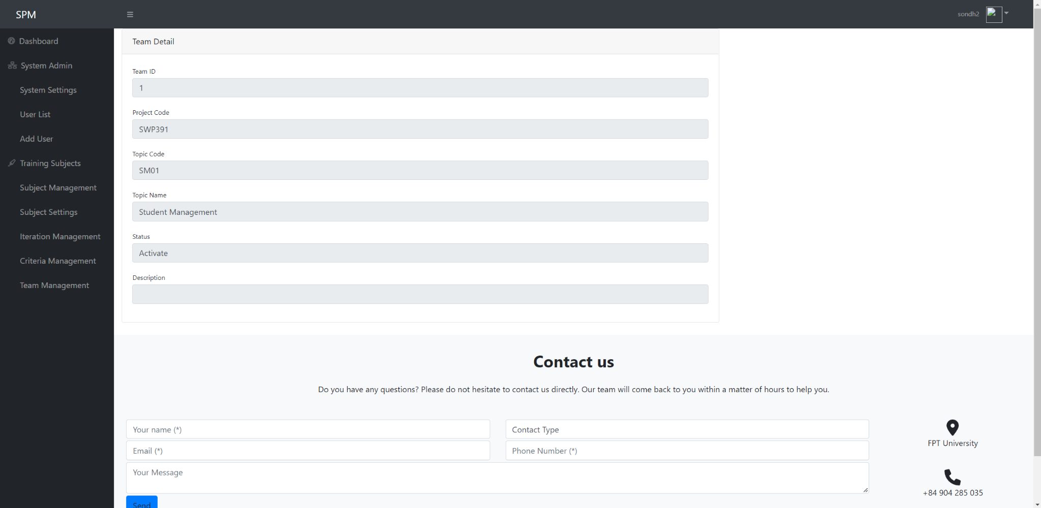

* Function Detai: When the trainer wants to view the list of information about the teams that have registered for the project, they can access the Dashboard, then select "Team Management". The system will navigate to the project team management page. Then, select "Detail" to view the detailed information of the team.

## 24. Student:

### 24.1. Student list:

* Function Trigger: When the trainer wants to see the list of information about the student Function Description:
* Actor: Trainer
* Purpose:trainer can change team , search , fliter , set team lead or change status
* Description:
* Screen Layout:
* Function Detai:

### 24.2. Student import:

## 25. Web Contact:

* Function Trigger: When the guests or the users want to contact website administrator
* Function Description:
* Actor: Guests, Users (Admin, Manager, Trainer, Student)
* Purpose: Allow user to input data into form in the web footer contact then submit the contact.
* Interface: A form in the web footer to allow user send contact information.
* Screen Layout:

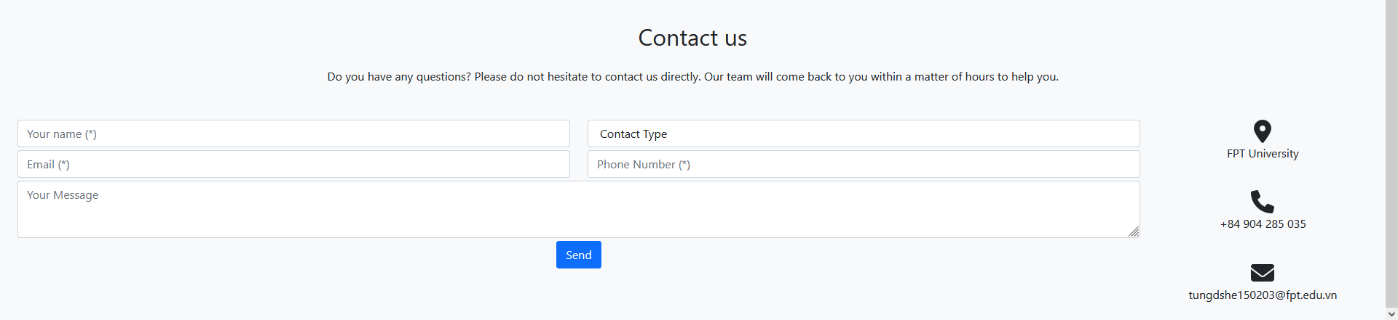

* Function Details:
* Guests or users enter the required information and then click the “Send” button. The data will then be sent into the database.